GIVE-AID
Charity & Donation Management Platform
PROJECT DOCUMENTATION

Project Name | Give-AID
Platform | ASP.NET Core MVC (.NET 8)
Database | Microsoft SQL Server (EF Core 8)
Dated | February - March 2026

Supervisor | Miss Kiran Shakeel
Batch | AI-202408E1
Serial No. | Student ID | Student Name
1. | Student1600501 | Tameen Fatima
2. | Student1600086 | Sana Siddiqui
3. | Student1598821 | Mahum Khan
4. | Student1599919 | Hafsah
5. | Student1599282 | Yumna Asim

Table of Contents
Contents | Page
Certificate of Completion | 4
Acknowledgement | 5
Introduction | 6
Problem Statement / Definition | 7
Customer Requirements Specifications | 8
1. Purpose of This Document | 8
2. Stakeholders | 8
3. Functional Requirements | 9
3.1 User Registration & Authentication | 9
3.2 User Profile Management | 9
3.3 Donation System | 10
3.4 NGO Directory | 10
3.5 Programmes (Events) Management | 11
3.6 Gallery | 11
3.7 Partner Management | 12
3.8 Contact & Query System | 12
3.9 Friend Invitation via Email | 13
3.10 Admin Dashboard & Management | 13
4. Non-Functional Requirements | 14
5. Constraints | 15
6. Acceptance Criteria Summary | 15
System Architecture and Design of the system complete website workflow & Interface snapshots | 16-33
Project Plan | 34
1. Project Overview | 34
2. Development Methodology | 34
3. Project Phases | 34
4. Resource Plan  5. Tools & Technologies Used | 35-37
GUI Standards Document | 38
1. Purpose | 38
2. Design Philosophy | 38
3. Color Palette | 38
4. Typography | 38
5. Button Standards | 39
6. Form Standards | 39
7. Navigation Standards | 39
8. Card & Component Standards | 39
9. Admin Table Standards | 40
10. Layout & Spacing | 40
11. Responsive Breakpoints | 40
12. Animations & Libraries  13. Icon Fonts | 40
Algorithms | 41
1. User Registration Algorithm | 41
2. User Login Algorithm | 41
3. Donation Processing Algorithm | 41
4. Admin Access Control Algorithm | 42
5. Image Upload Algorithm | 42
ERD | 43
Interface Design Document | 44
Workflow Diagrams ( Admin & User ) | 45-46
Task Sheet | 47-48
Project Review & Monitoring Report | 49
Unit Testing Checklist 50-51
Final Submission Checklist 51-52

CERTIFICATE OF COMPLETION
This is to certify that
Tameen Fatima ,
Mahum Khan ,
Hafsah ,
Sana Siddiqui & Yumna Asim

Have Successfully Completed Their ACCP-AI HDSE-I E-Project
Submitted To: Aptech Computer Education
Date of Issue : February 20th, 2026

ACKNOWLEDGEMENT
First and foremost , we are deeply thankful to Almighty Allah for granting us the strength, patience, and ability to complete this project successfully. We would like to express our heartfelt gratitude to our respected teacher, Miss Kiran Shakeel, for her invaluable guidance, continuous support, and encouragement throughout the development of our project
“Give AID - Charity & Donation Management Platform”
Her supervision not only kept us on the right track but also enhanced our learning experience through exposure to new ideas and technologies. We are also sincerely thankful to our parents and friends for their constant motivation, moral support, and assistance during every phase of this project. Finally, we would like to extend our appreciation to the E-Project Team at Aptech Head Office for their valuable feedback, resources, and overall support, which played a key role in the successful completion of this project.

INTRODUCTION
Give-AID is an online charity and donation management platform that connects donors with verified NGOs, upcoming charitable events, and causes that genuinely need support. Whether you're here to give for the first time or you've been donating for years, we built this platform to make the experience simple, transparent, and worth your trust.
We started with one honest observation: most people want to donate, but they don't know who to trust. Outdated NGO websites, cash-only drives, no receipts, no records — it all adds up to doubt. Give-AID removes that doubt. Every organization listed on our platform is admin-verified. Every donation you make is saved to your personal history. Every rupee goes exactly where you chose to send it.
Browse our NGO directory, explore upcoming events, or make a donation in under a minute — no paperwork, no phone calls, no uncertainty. Just a clean, secure platform that respects your generosity and handles the rest.
"Give Help, Change Lives." That's not just our tagline — it's the only thing we're here to do.

PROBLEM STATEMENT / DEFINITION
Standards plan:
- Every code block must have comments.
- The logic of the program needs to be explained. Proper documentation should be maintained.
- Complete Project Report along with synopsis, code and documentation should be prepared.

Documentation:
Documentation is one of the most important activities during the development of a project. The documentation of an ideal project will be in the form of a project report comprising of the following documents:
- Certificate of Completion.
- Table of Contents.
- Problem Definition.
- Customer Requirement Specification.
- Project Plan.
- E-R Diagrams.
- Algorithms.
- GUI Standards Document.
- Interface Design Document.
- Task Sheet.
- Project Review and Monitoring Report.
- Unit Testing Check List.
- Final Check List.

CUSTOMER REQUIREMENTS SPECIFICATIONS – GIVEAID

1. Purpose of This Document :
This document defines what Give-AID is supposed to do — from the perspective of the people who actually use it. Not just technically, but in plain terms: what users need, what admins need, what the system must handle reliably, and what "done right" looks like for each feature.
Every requirement here traces back to a real problem someone was having before Give-AID existed.
2. Stakeholders :
Stakeholder | Who They Are | What They Need from Give-AID
Guest / Visitor | Anyone browsing without an account | Publicly accessible information about NGOs, events, gallery, and how to donate
Registered User / Donor | Signed-up individuals who donate | A secure, fast, trustworthy way to discover causes and give money
Administrator | Platform manager with full access | Complete control over all platform content, users, and activity
NGO / Organization | Charitable organizations being listed | Accurate, professional representation on the platform

3. Functional Requirements :

3.1 User Registration & Authentication
Users need to create an account to donate, submit queries, or invite friends. The registration process should feel quick and not ask for more than what's necessary.
The system must:
- Allow new users to register with full name, email address, password, phone number, and optional address and profession
- Validate that all required fields are filled before submission
- Confirm that the entered password and confirm password fields match exactly
- Enforce a minimum password length of 6 characters
- Reject registration if the email address is already in use, with a clear message
- Automatically log the user in after successful registration
- Allow users to log in using their registered email and password
- Redirect admin users to the Admin Dashboard and regular users to the Home page upon login
- Support session-based authentication using User Id, User Name, and User Role
- Allow users to log out, which clears all session data

3.2 User Profile Management
Once registered, users should be able to keep their information up to date and have full control over their account security.
The system must:
- Display a profile page showing the user's personal details and complete donation history
- Allow users to edit their name, phone number, address, and profession
- Require name and phone to always be present — neither can be left empty on update
- Allow users to change their password by first verifying the current one
- Reject the password change if the current password entered does not match
- Confirm that the new password and confirm new password fields match before saving
- Enforce the same minimum 6-character length on new passwords
- Reflect the updated display name in the navigation bar immediately after profile edit

3.3 Donation System
This is the core of Give-AID. The donation flow needs to be fast, reliable, and completely trustworthy. Users should never feel unsure about whether their payment went through.
The system must:
- Require the user to be logged in before accessing the donation page — unauthenticated visitors see a message and are redirected to login
- Allow users to enter a donation amount, select a cause, and provide card payment details
- Validate that the donation amount is greater than zero
- Require a cause to be selected before submission can proceed
- Require the cardholder name to be entered
- Strip all spaces and dashes from the card number and validate that exactly 16 digits remain
- Require a card expiry date, CVV, and card type (Visa, Mastercard, etc.) — all fields mandatory
- Save the donation record with the user's ID, amount, cause, card holder name, card number, card type, and the date and time of donation
- Redirect to a success confirmation page after a valid donation, displaying the donated amount and selected cause
- Store cause and amount in TempData to persist across the redirect
- Block direct access to the success page if no donation was just made

3.4 NGO Directory
Users and guests need to be able to discover verified charitable organizations easily. The directory is the heart of what makes Give-AID a trustworthy platform.
The system must:
- Display all active NGOs publicly — no login required
- Show each NGO with its name, description, logo, contact email, phone number, and website link
- Allow the administrator to add a new NGO with all relevant fields and an optional logo upload
- Default to a placeholder logo if no image is uploaded
- Allow the administrator to edit any NGO's details including toggling its active/inactive status
- Allow the administrator to delete an NGO permanently
- Exclude inactive NGOs from the public directory while keeping them in the admin panel

3.5 Programmes (Events) Management
Charity events are how organizations build community and draw new donors in. The events section must be informative enough that someone could actually decide to attend based purely on what they read here.
The system must:
- Display all events publicly, ordered by event date descending
- Show event title, description, category, date, location, and event image
- Distinguish between upcoming and past events using an IsUpcoming flag
- Display the three most recent upcoming events on the home page as a preview
- Provide a dedicated event detail page for each event
- Allow the administrator to add events with a title, description, category, location, event date, image upload, and upcoming/past status
- Allow the administrator to edit or delete any event
- Default to a placeholder image if no event image is uploaded

3.6 Gallery
The gallery exists to show donors proof of impact — real photos from real charitable work. It needs to be easy to browse and easy to manage.
The system must:
- Display gallery images publicly with captions and upload dates
- Allow filtering of gallery images by category
- Order images by upload date, newest first
- Show a preview of the six most recent gallery images on the home page
- Allow the administrator to upload new images with a caption and category
- Allow the administrator to delete images — deleting from the gallery must also remove the image file from the server
- Require an image file to be selected before the upload form can be submitted

3.7 Partner Management
Partners and supporting organizations are listed to build credibility. The section should feel professional and current.
The system must:
- Display all active partners publicly with company name, logo, description, and website
- Allow the administrator to add, edit, and delete partner entries
- Support logo uploads for partner entries with a fallback default logo
- Allow the administrator to toggle partner visibility with an active/inactive status

3.8 Contact & Query System
Users need a way to reach out, and they need to know their message was received. Administrators need to be able to manage this without it becoming overwhelming.
The system must:
- Provide a public contact form accepting full name, email, subject, and message — no login required
- Save contact messages to the database with a timestamp and unread status
- Allow the administrator to mark contact messages as read
- Allow the administrator to delete contact messages
- Provide a Help Centre page where logged-in users can submit support queries with a subject and message
- Save queries with the user's ID, subject, message, submission timestamp, and a default unreplied status
- Allow the administrator to view all queries sorted by reply status — unanswered first
- Allow the administrator to submit a reply to any query, which sets the replied status and records the reply timestamp
- Display each user's submitted queries and any admin replies in a personal My Queries page

3.9 Friend Invitation via Email
This is a small but meaningful feature — letting existing donors grow the community organically.
The system must:
- Allow logged-in users to send an invitation email to a friend using their email address and name
- Send the email via Gmail SMTP (SSL, port 587) using the platform's sender account
- Compose the email with the sender's name, a brief invitation message, and the platform URL
- Display a success message when the email is sent successfully
- Display an error message if the email fails to send, with the reason shown

3.10 Admin Dashboard & Management
The admin needs to see everything at a glance and act on anything without friction. The dashboard is command central.
The system must:
- Display a dashboard showing recent donations, total users, all NGOs, all events, all partners, pending queries, unread messages, and gallery items
- Apply the IsAdmin() role check to every single admin action — any non-admin session is redirected to login immediately
- Allow the administrator to view all registered users ordered by registration date
- Allow the administrator to delete any user account except their own — attempting self-deletion must return a clear error
- Allow the administrator to view all donations with the total donated amount calculated and displayed
- Provide separate management panels for NGOs, Events, Gallery, Partners, Queries, and Contact Messages — each with full create, read, update, and delete capabilities

4. Non-Functional Requirements
These are the standards Give-AID holds itself to beyond just "does it work."
Requirement | Standard
Security | Every admin route checks session role before executing. No admin feature is accessible without an active admin session.
Validation | All form inputs are validated server-side in C#. Client-side validation is a convenience, not the safety net.
Performance | Page responses under normal load should feel immediate — no full-page waits for simple CRUD actions.
Reliability | Donation records must never be lost. Every successful transaction is persisted before the success page renders.
Usability | Any user who has never seen the platform before should be able to complete a donation without needing instructions.
Responsiveness | All pages must work cleanly on desktop and mobile using Bootstrap 4's 12-column responsive grid.
Maintainability | All schema changes are tracked through EF Core Code-First migrations. No manual SQL changes to production.
File Storage | Uploaded images are stored under wwwroot/images with GUID-generated filenames to prevent conflicts. Deleted records remove the file from disk.
Session Management | Sessions store UserId, UserName, and UserRole. Logout clears all three. Protected pages redirect to login if UserId is null.

5. Constraints
- Payment processing is simulated — no real payment gateway (Stripe, PayFast) is integrated in this version
- Email functionality depends on Gmail SMTP availability — if the SMTP server is unreachable, invitation emails fail gracefully with an error message
- Image storage is local to the server — no cloud storage (Azure Blob, S3) is used in this version

6. Acceptance Criteria Summary
The system is considered complete and ready for submission when:
- A new user can register, log in, donate to a cause, and view their donation in their profile history — all without admin intervention
- An admin can log in, add a new NGO with a logo, create an event, upload a gallery image, reply to a user query, and view the total donations — all from the dashboard
- Every admin route redirects non-admin users to the login page, without exception
- All 11 EF Core migrations apply cleanly to a fresh SQL Server database
- All 17 unit test cases pass without failure

System Architecture and Design of the System Complete Website Workflow and Interface Snapshots
Home Page
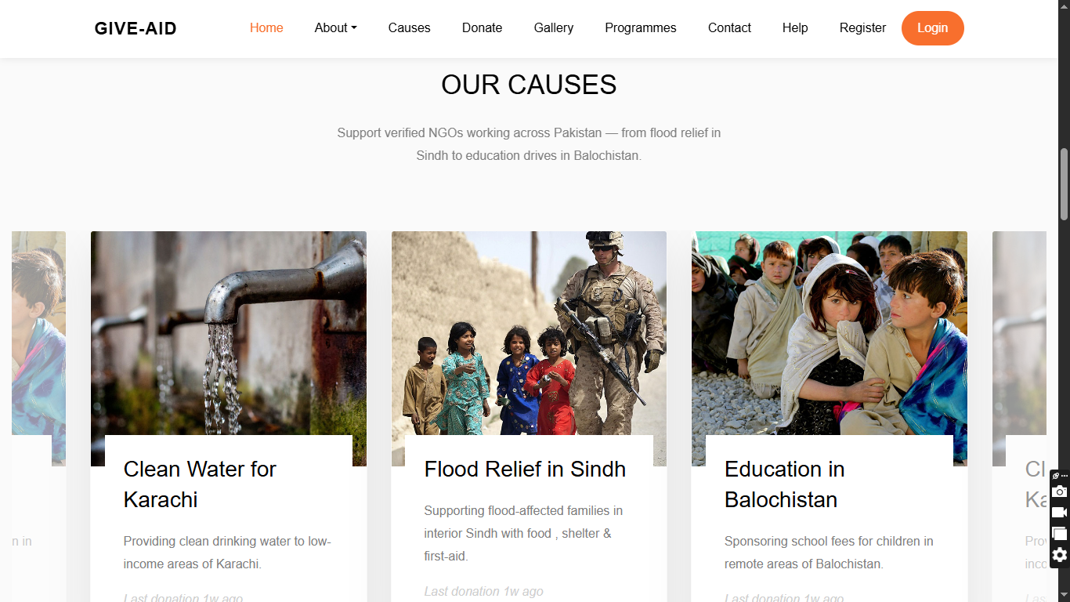
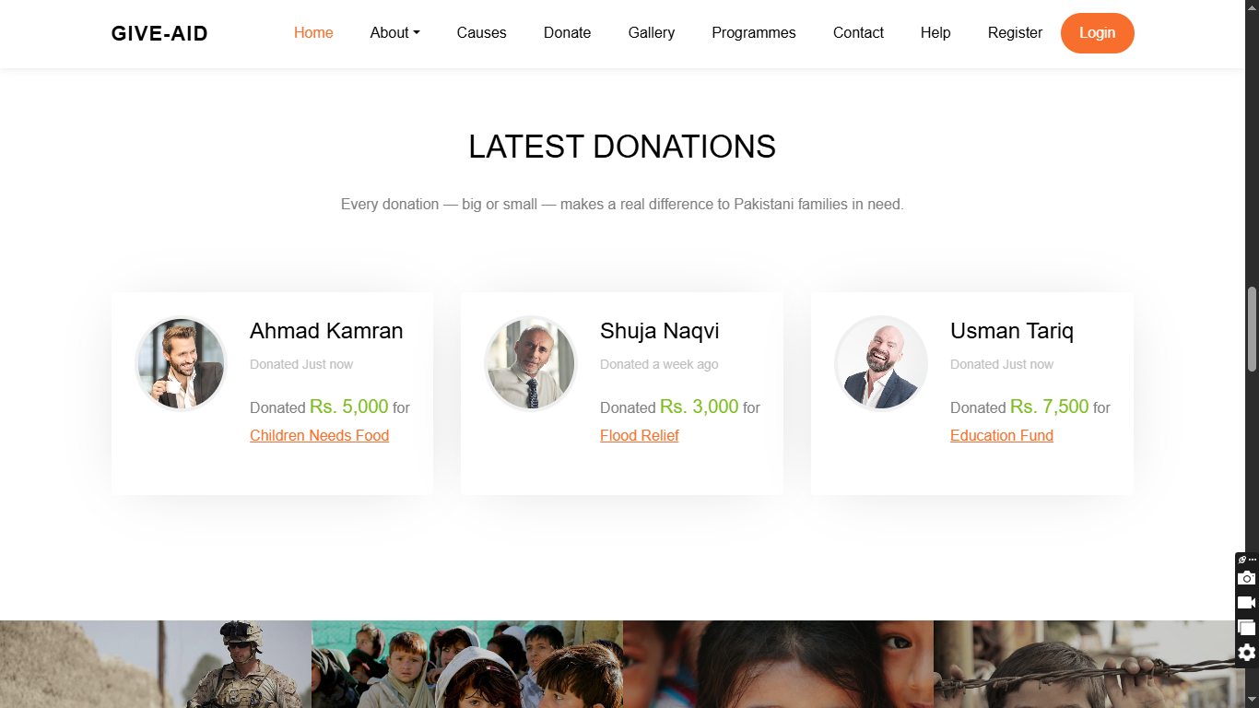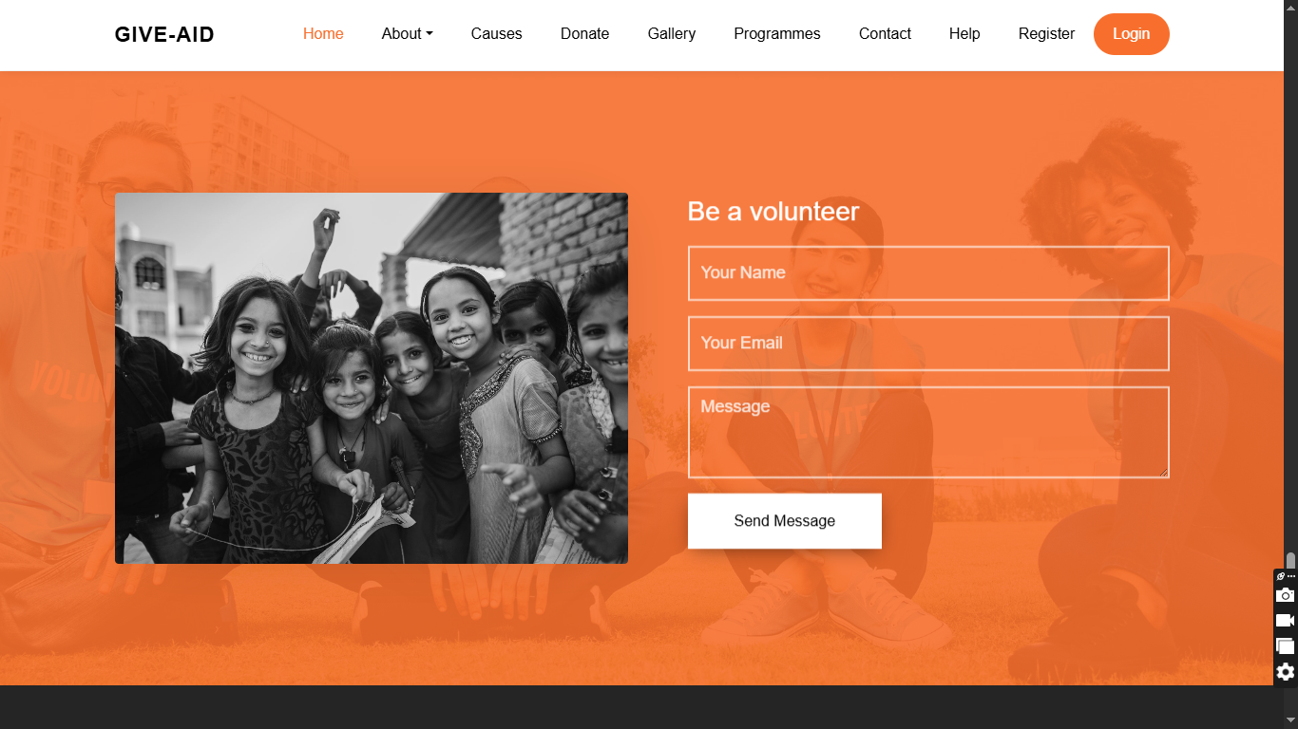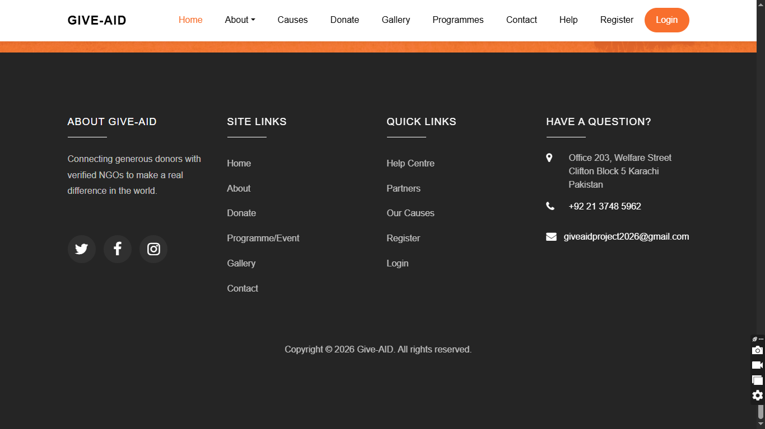
About Us / Our Mission 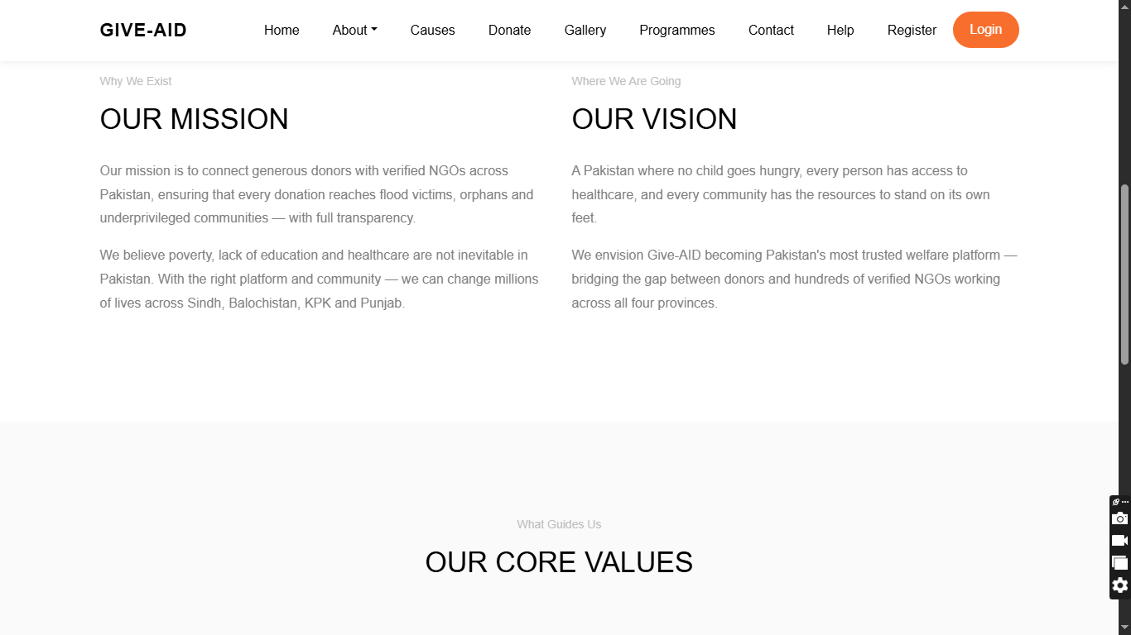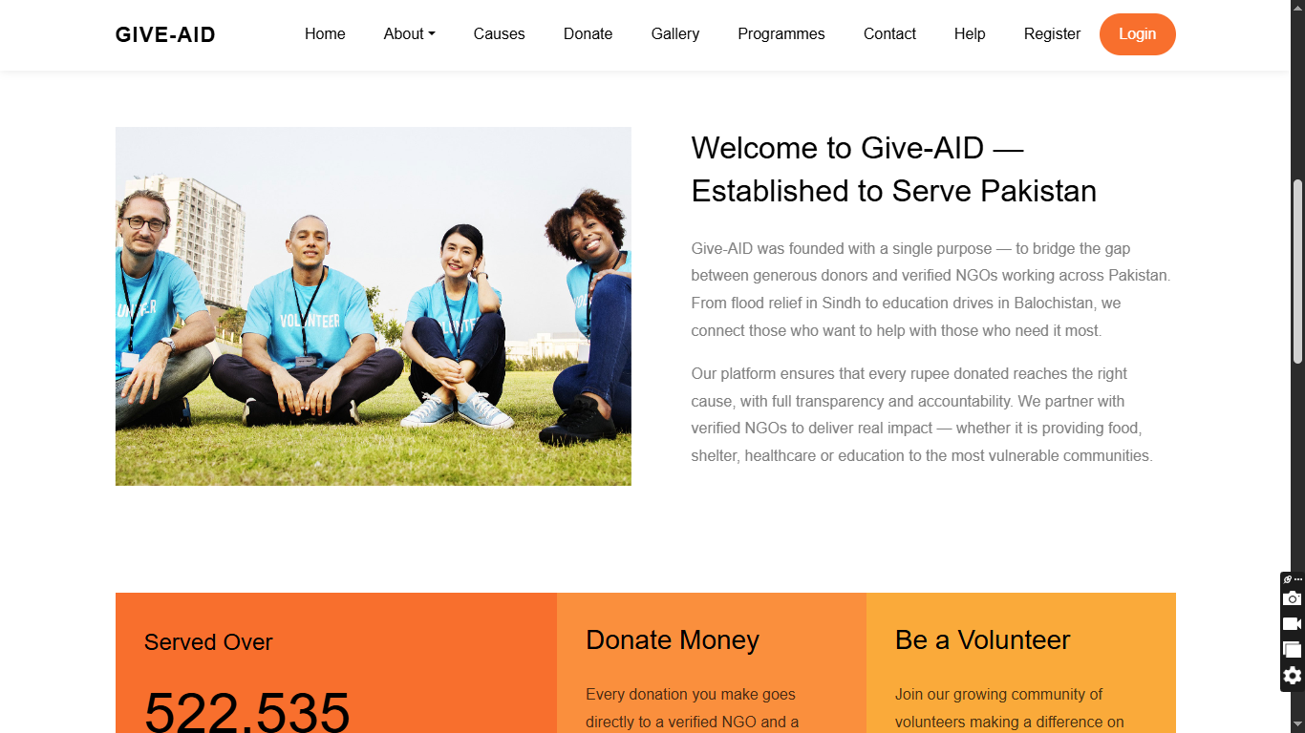

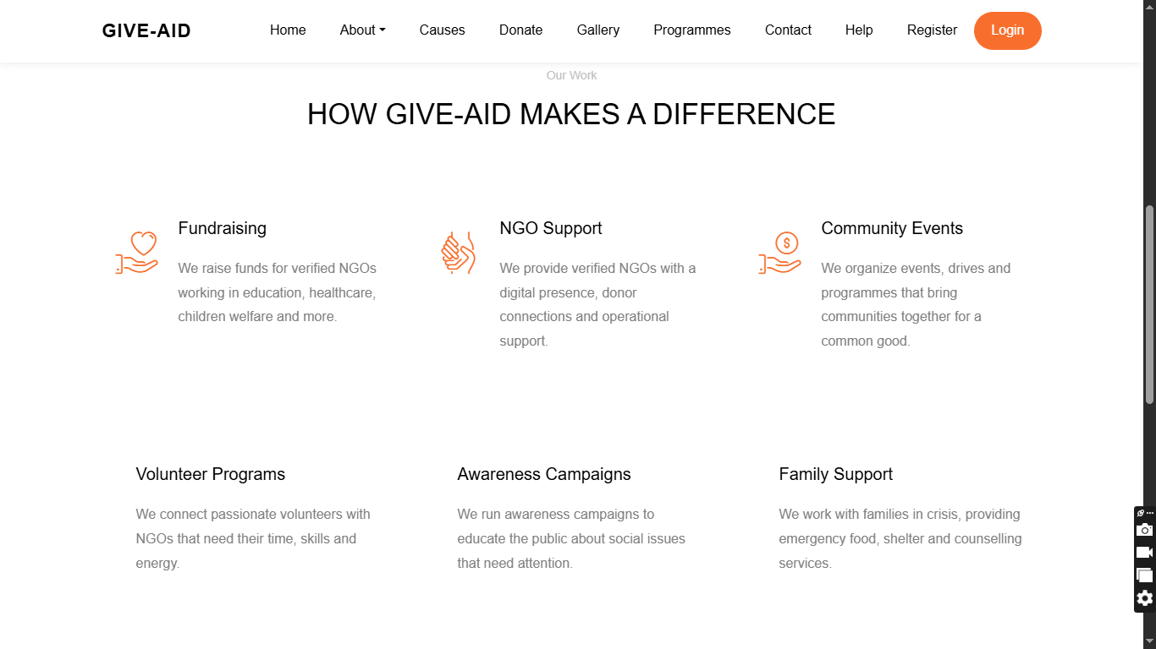
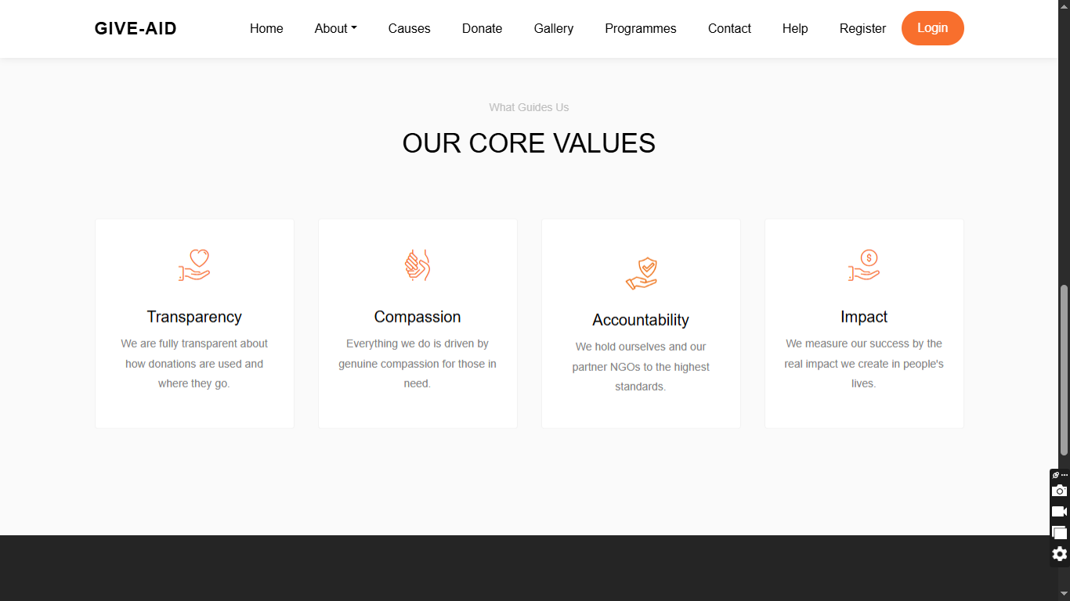
Our Team & Our Partners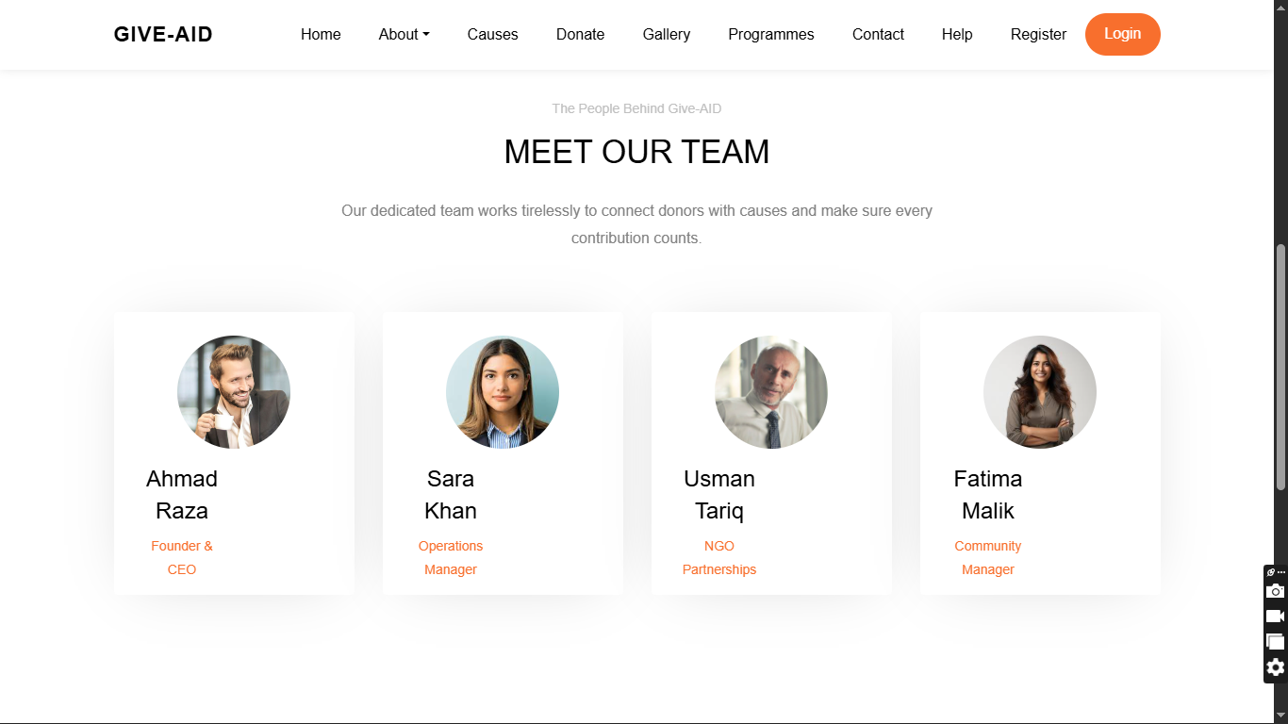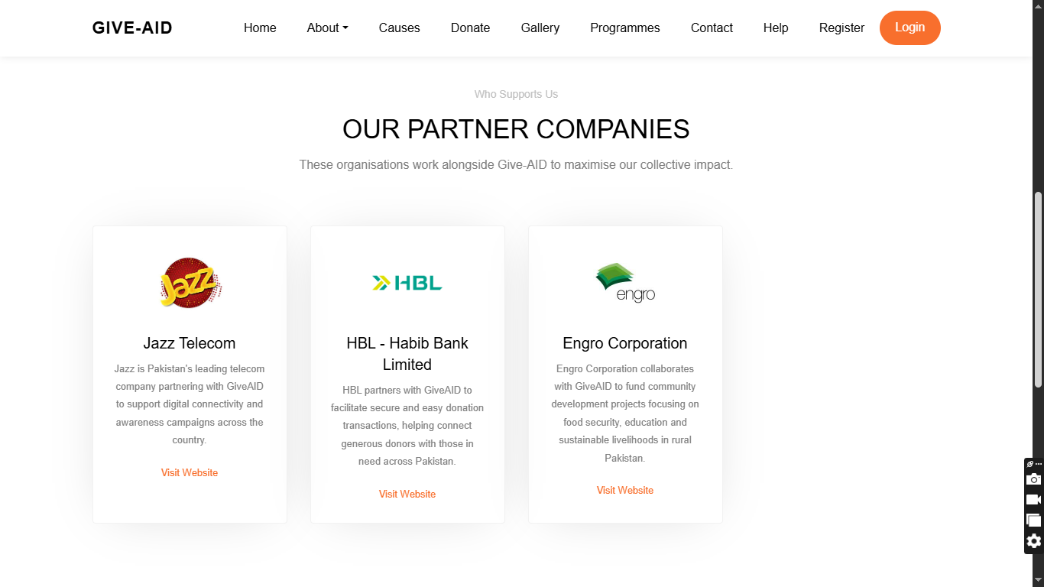
Career & Achievements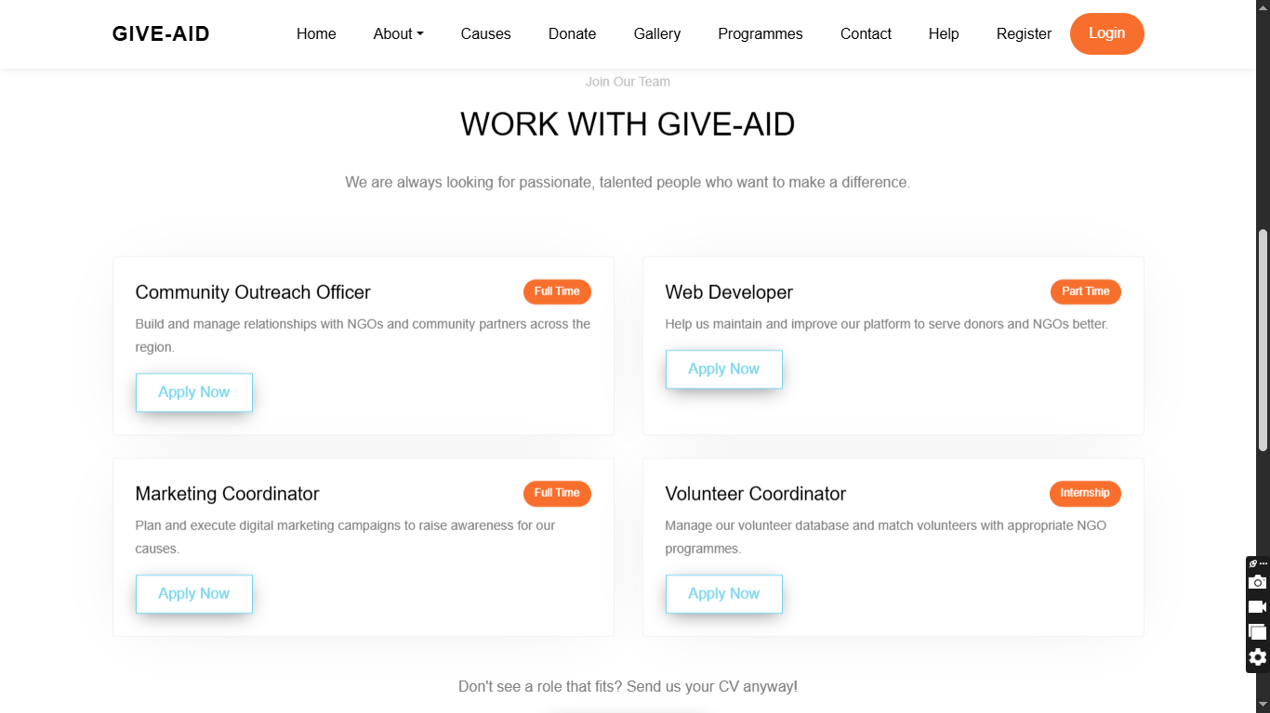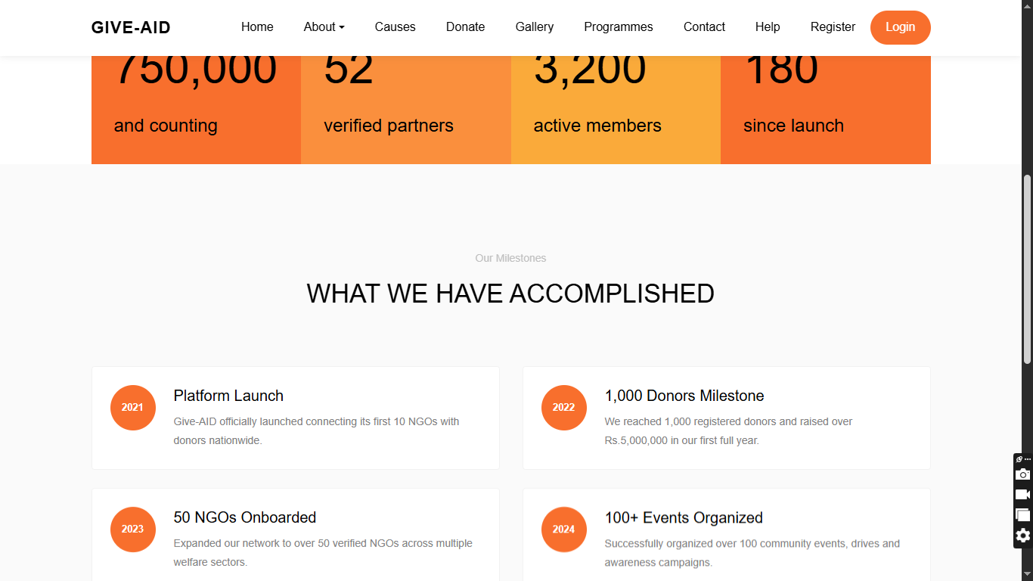
Our Supporters & NGOs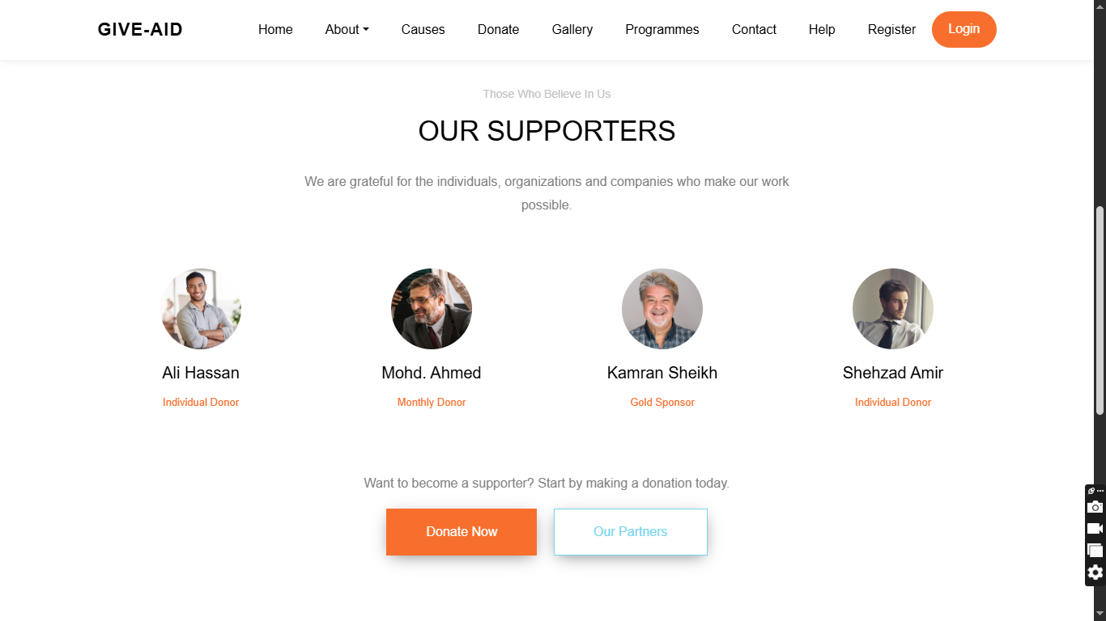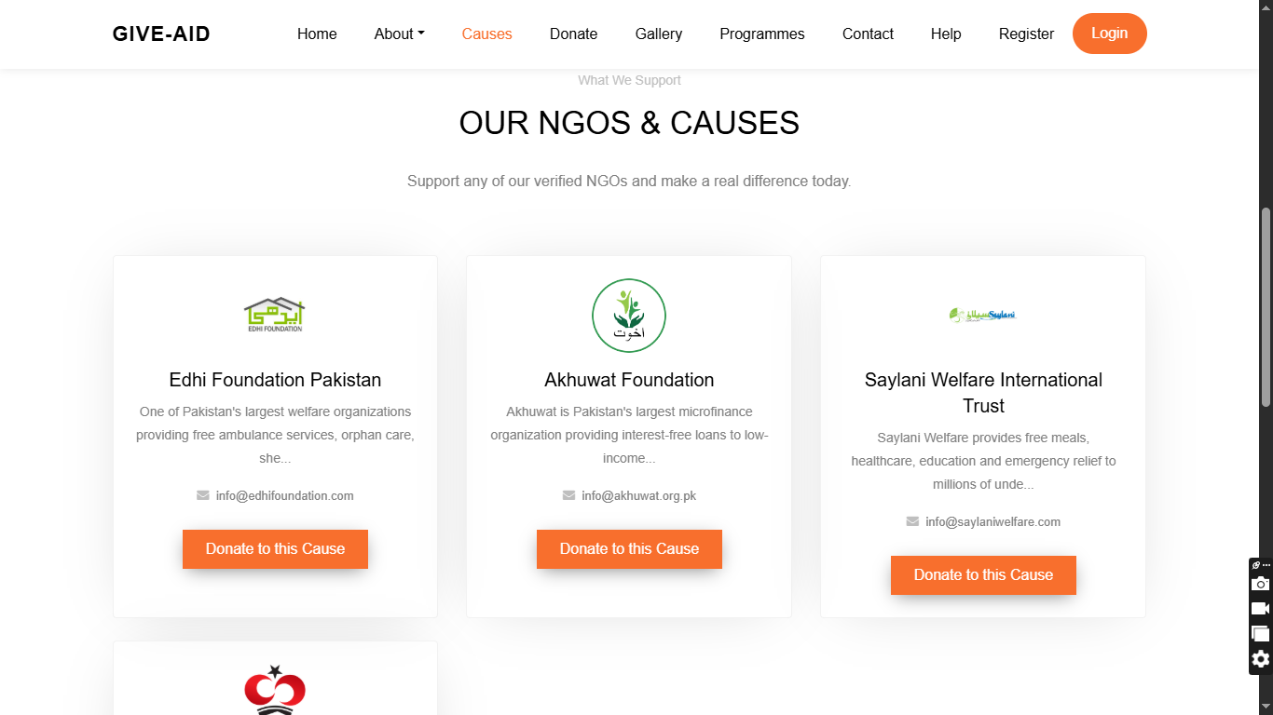
Donation Page & Gallery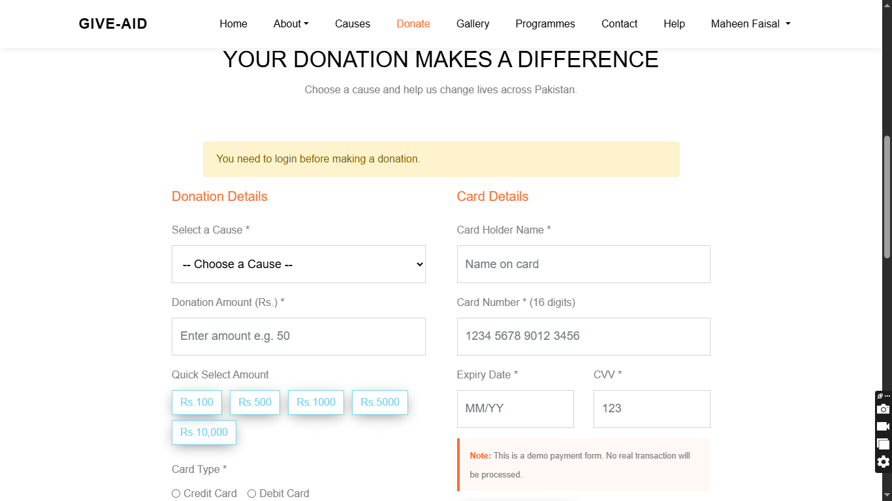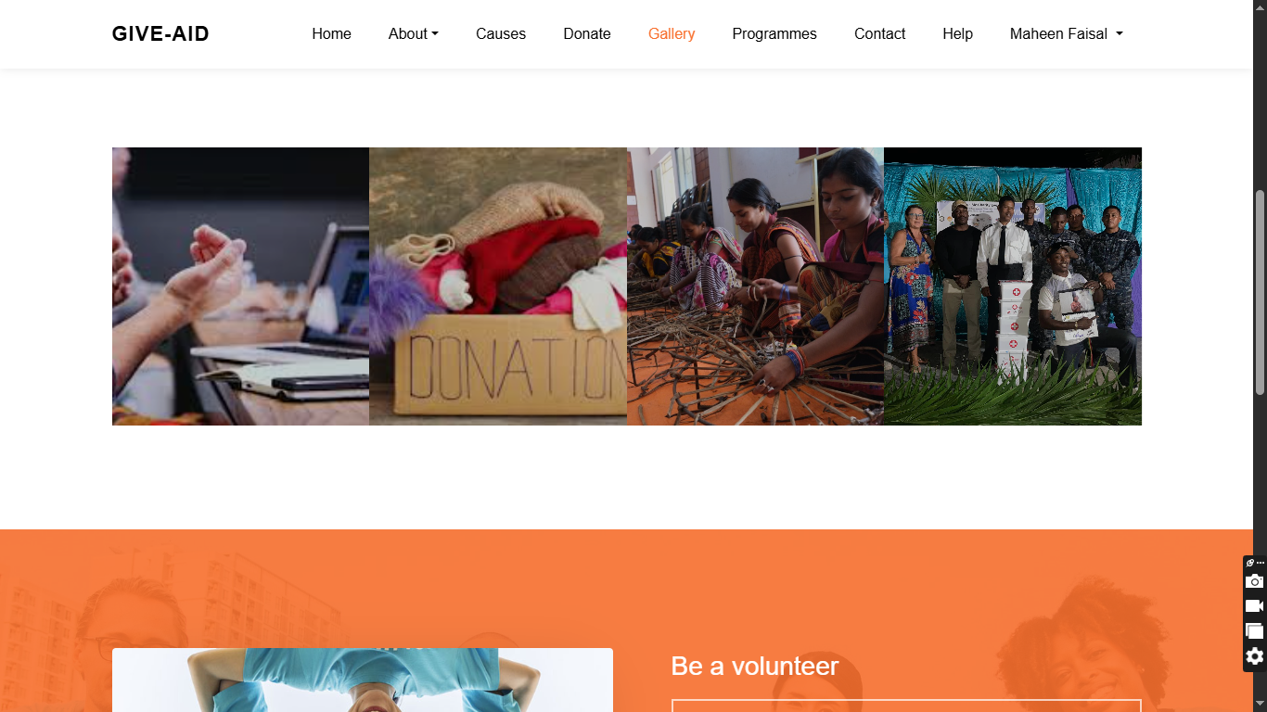
Programmes & Contact Page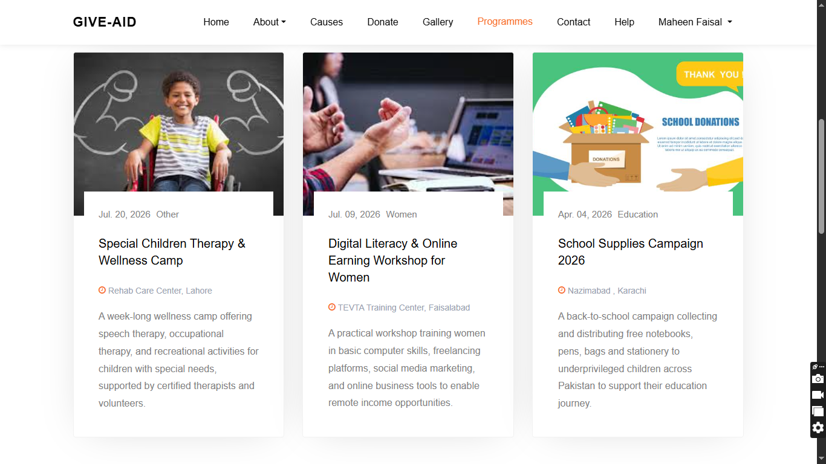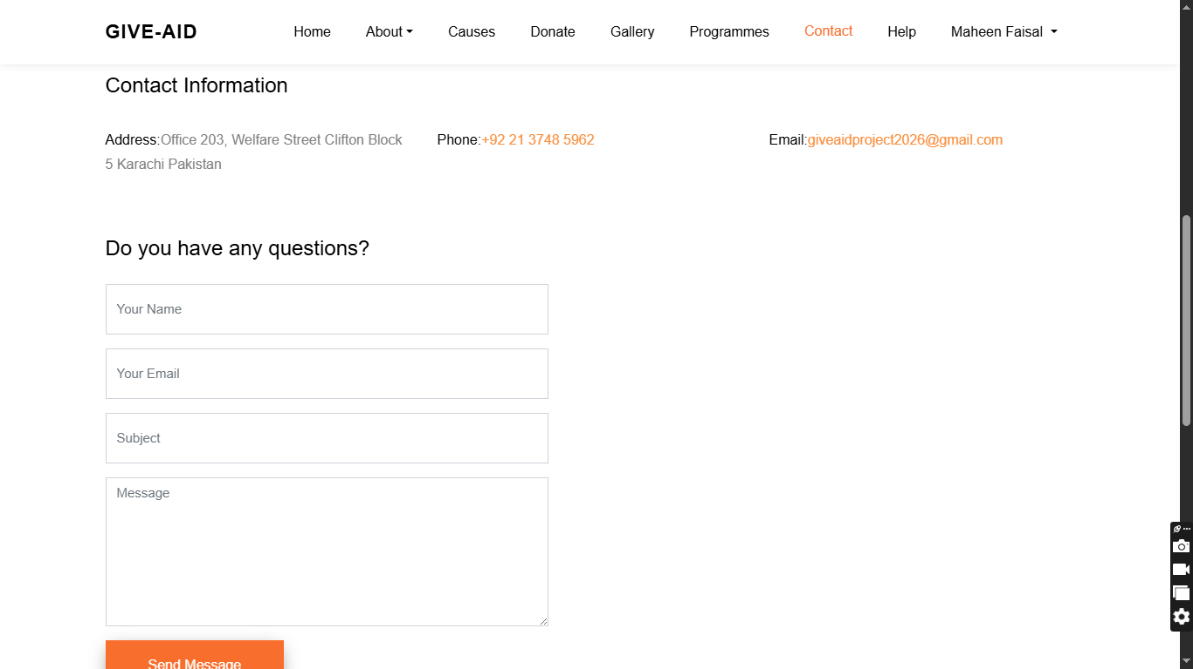
Help Centre & User Profile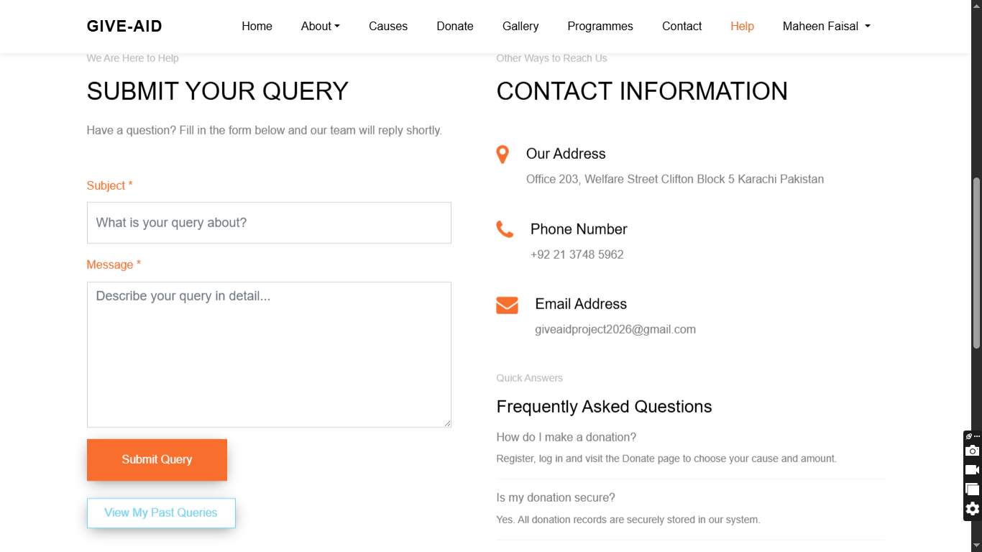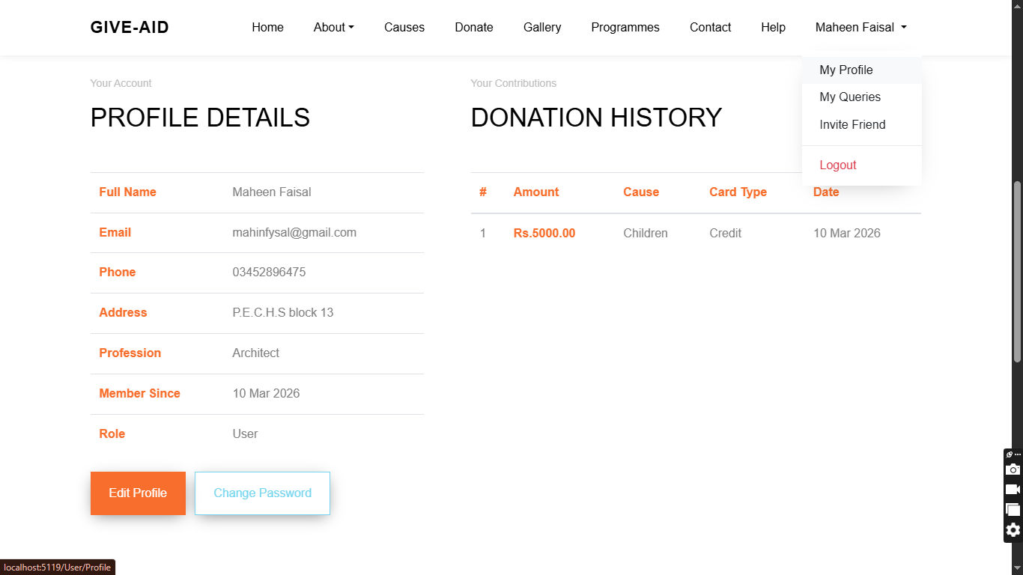
User Queries & Invite Friend 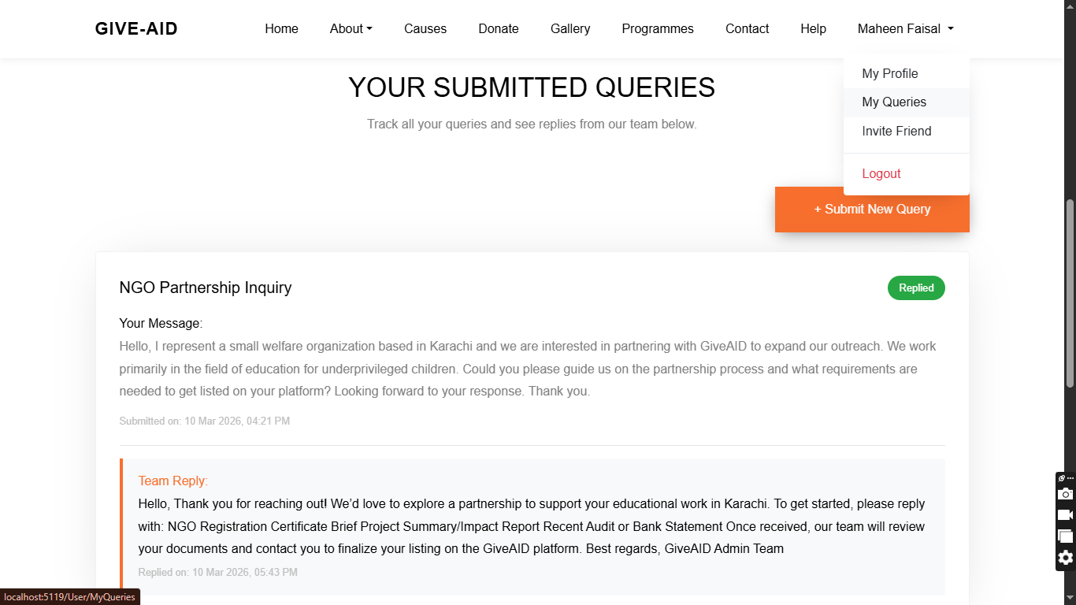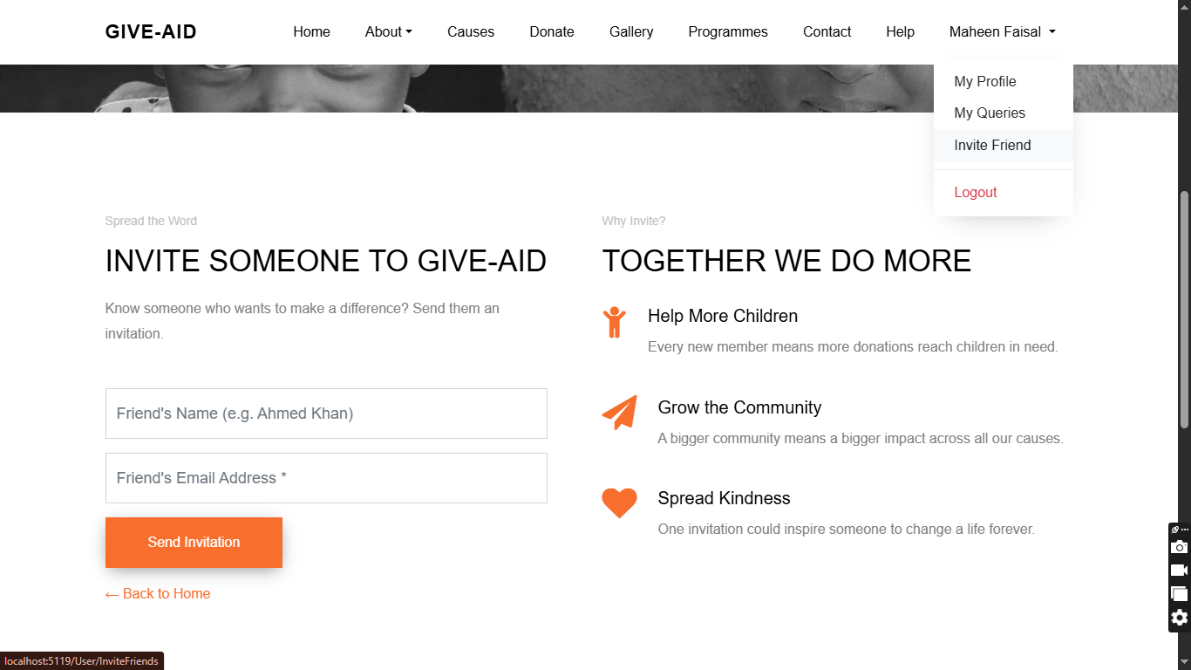
Register & Login Forms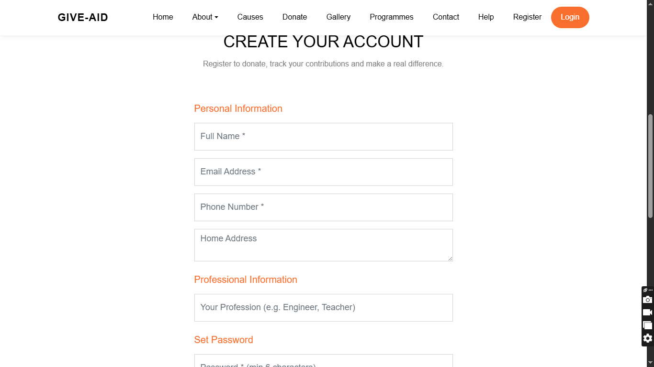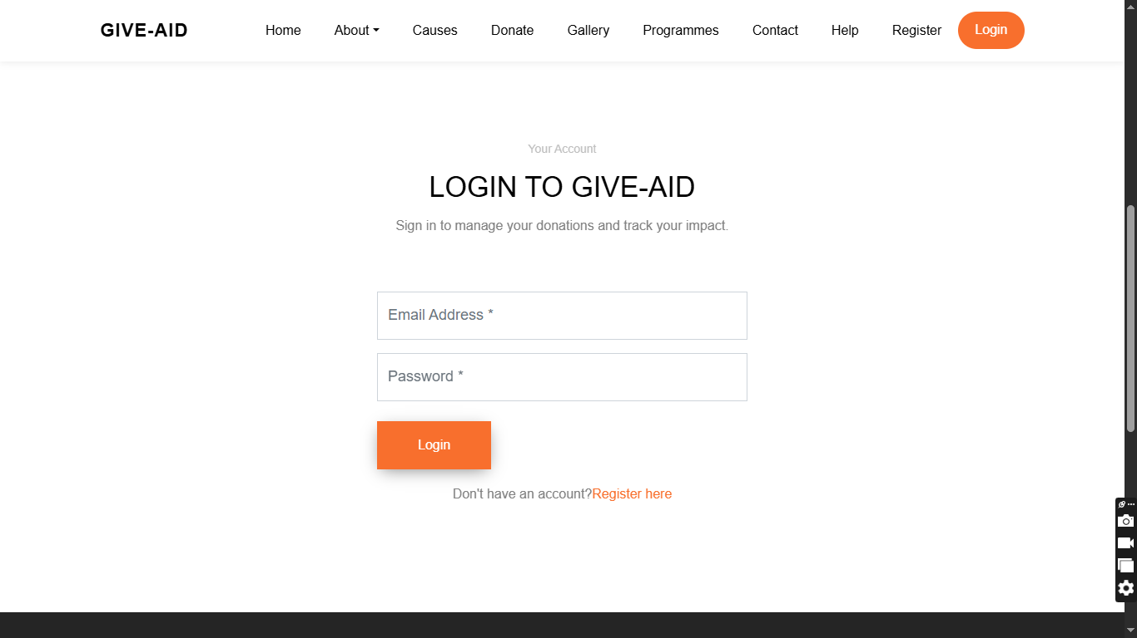
Admin Dashboard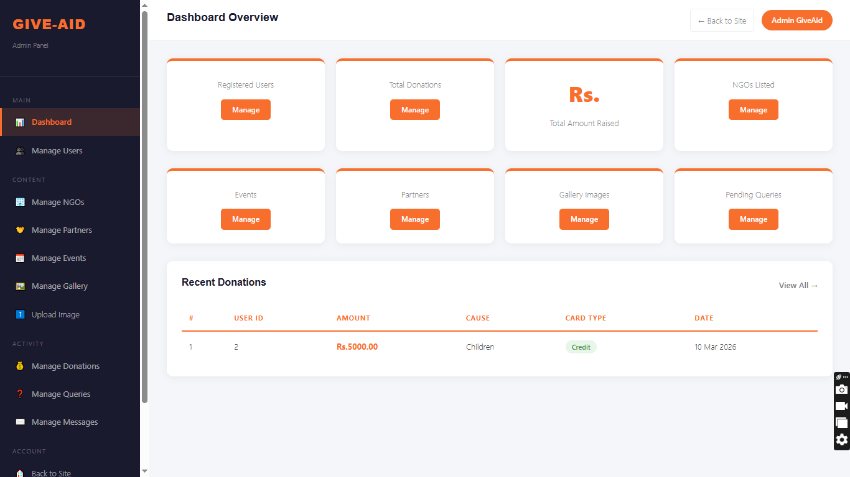Upload Image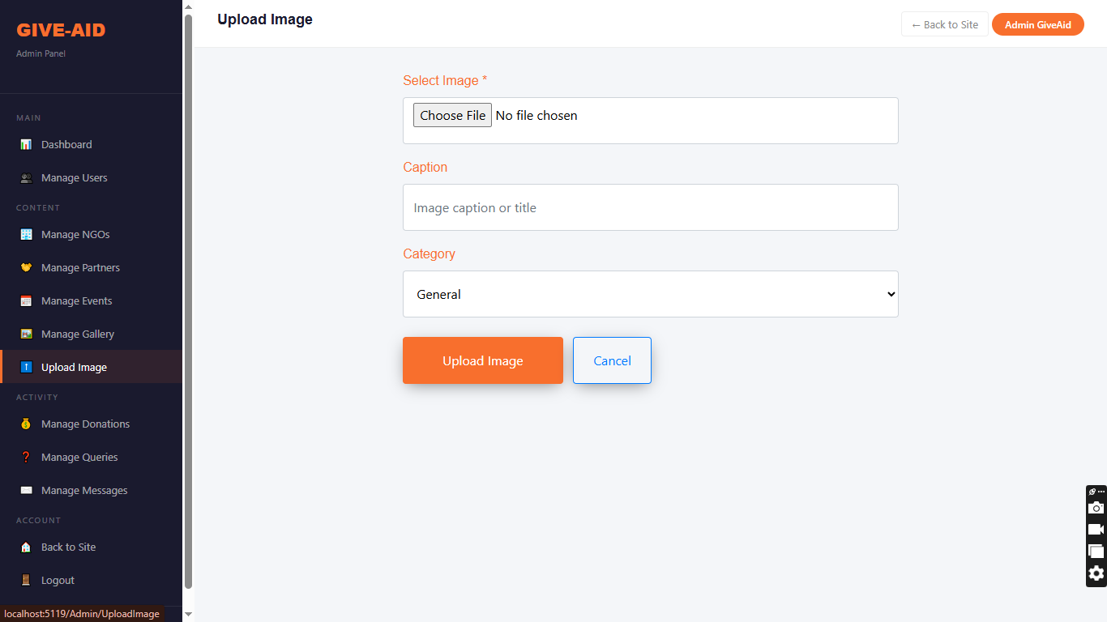All Donations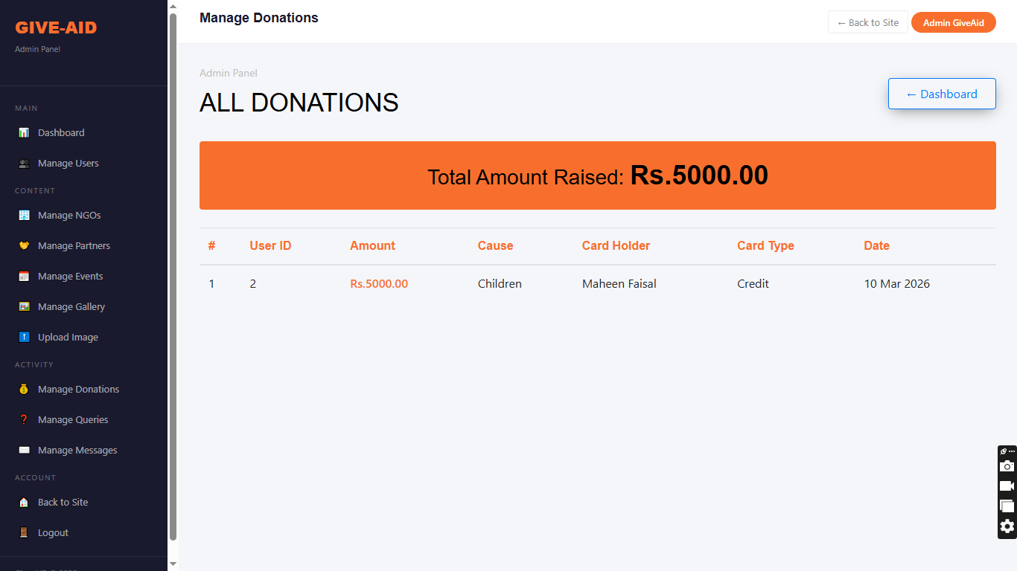User Queries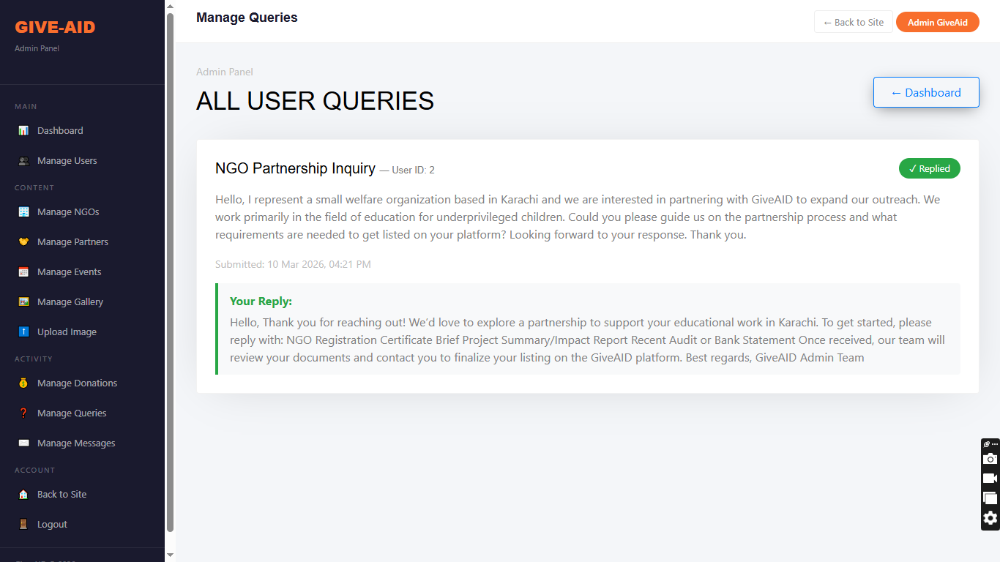All Contact Messages to Admin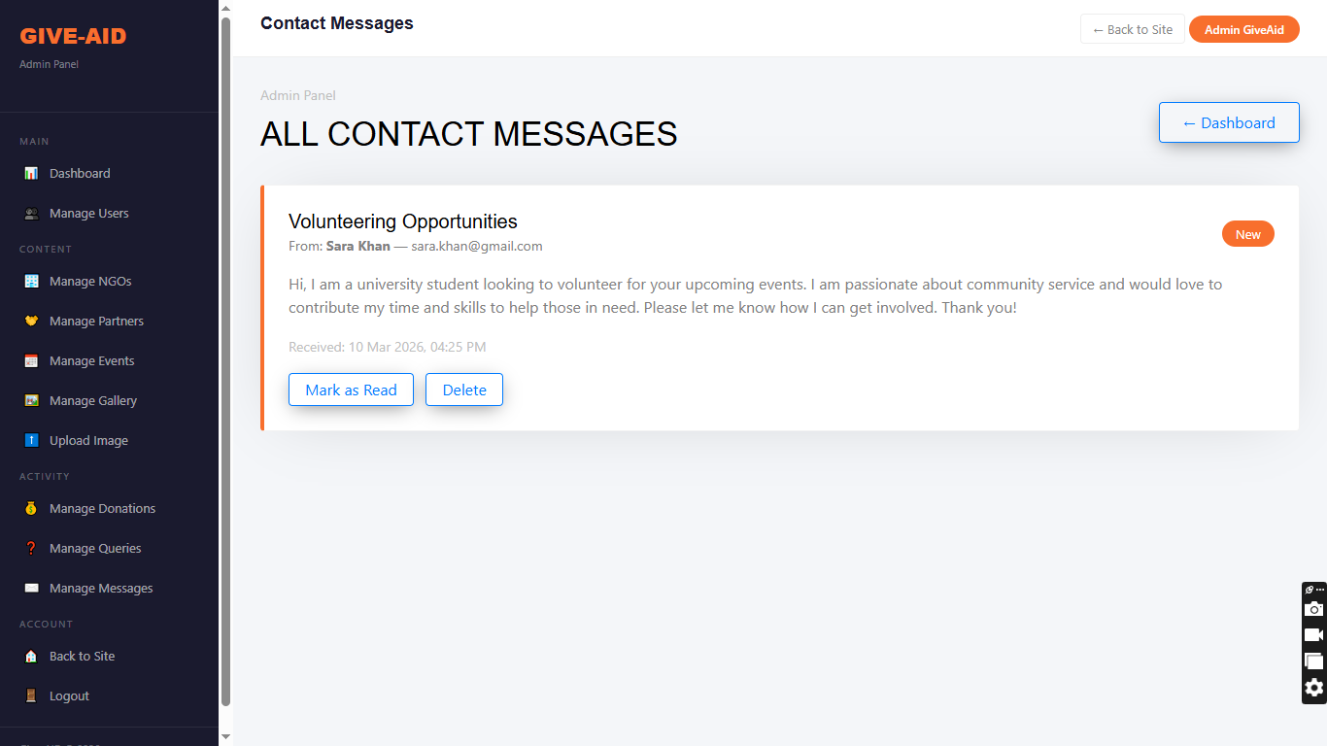All Registered Members (Users)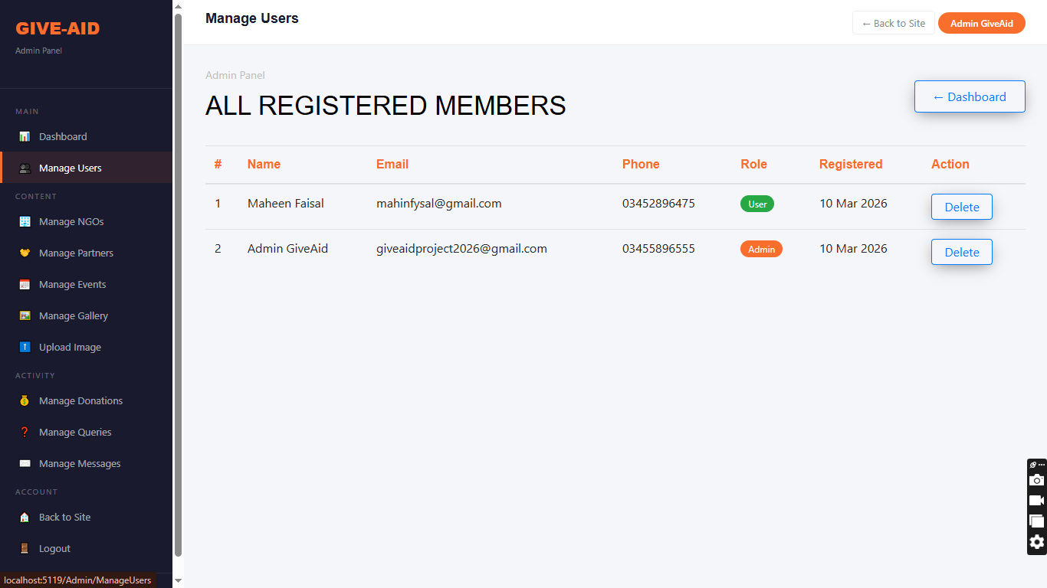All NGOs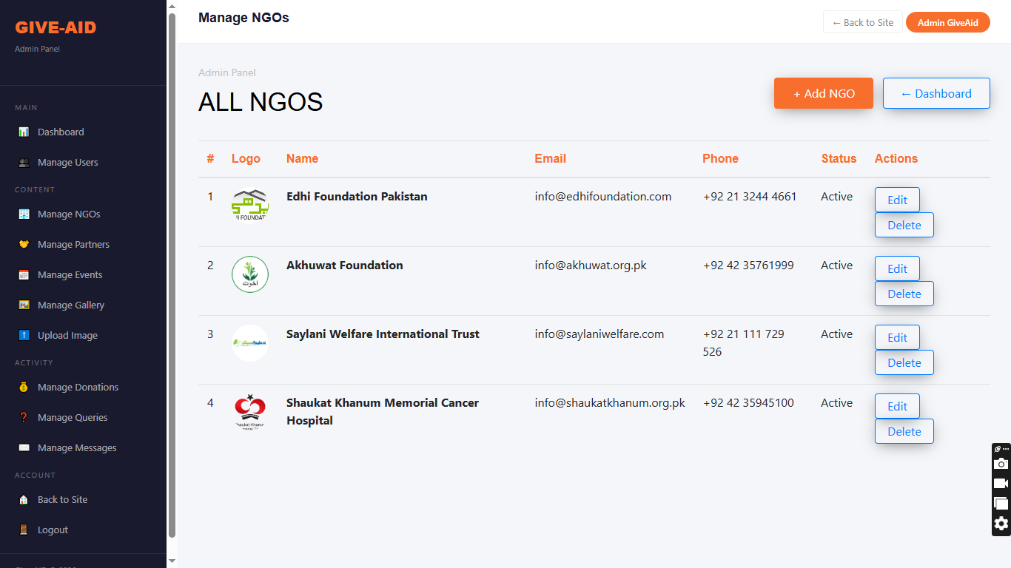All Partners (Companies)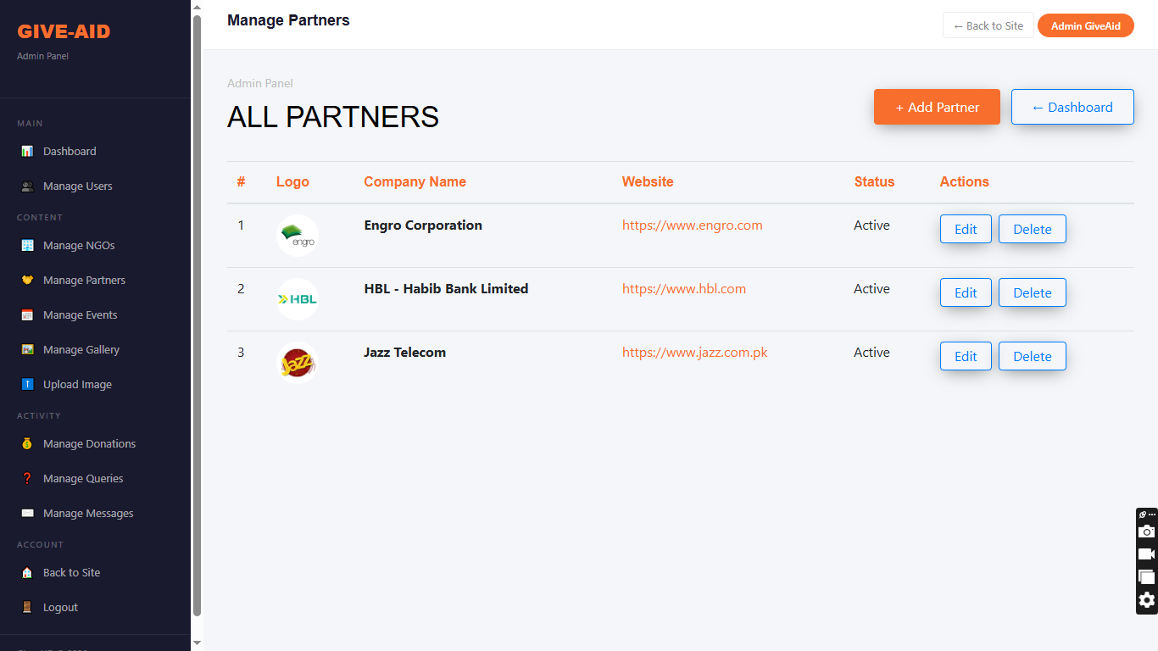All Events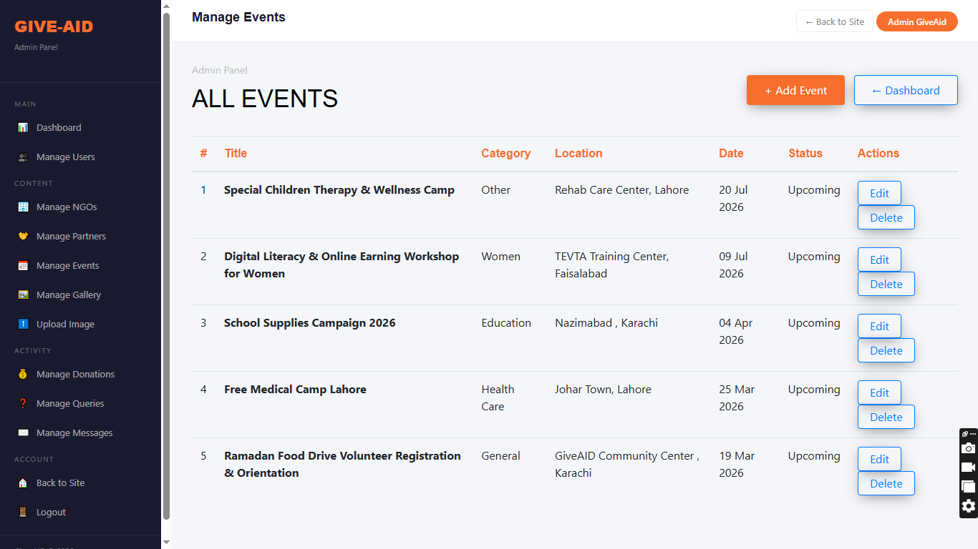Gallery Images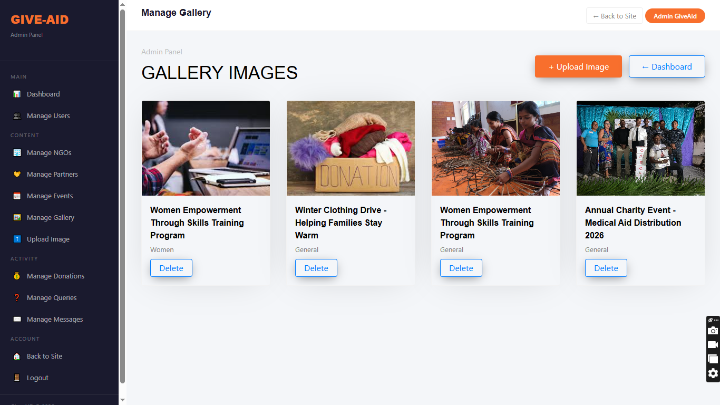
PROJECT PLAN
1. Project Overview
Give AID is a full-stack web-based charity and donation management system built using ASP.NET Core MVC (.NET 8) and Microsoft SQL Server. The goal was to design, develop, test, and document a complete working platform within an 4-week development cycle — from initial requirement gathering all the way through to final submission.
2. Development Methodology
The project followed an Incremental Development approach — meaning we built and tested one module at a time rather than trying to build everything at once. Each module was completed, reviewed, and signed off before the next one began. This kept the codebase clean and made debugging significantly easier.
PROJECT PHASES
Phase | Name | Duration | Key Activities | Deliverable
Phase-1 | Requirements & Planning , Database Design | Week 1 | Identified all stakeholders (Guest, User, Admin). Defined functional & non-functional requirements. Agreed on tech stack: ASP.NET Core MVC, EF Core, SQL Server, Bootstrap 4. Prepared initial task assignment sheet. & Designed full relational schema for all 8 entities. Defined primary keys, foreign keys, and nullable fields. Set up EF Core Code-First project. Applied InitialCreate migration and confirmed all tables in SQL Server. | Approved requirements document & Working database with all base tables
Phase-2 | Backend & Frontend | Week 2 | Built all four controllers: HomeController, UserController, AdminController, DonationController. Configured session middleware and IsAdmin() guard. Implemented GUID-based image upload, Gmail SMTP, and all 11 EF Core migrations & Built _Layout.cshtml and _AdminLayout.cshtml. Designed all Razor views. Applied Bootstrap 4 responsive grid, Owl Carousel, AOS, Magnific Popup, and Animate.css throughout. | Fully functional backend with all routes and business logic & Complete responsive frontend connected to all backend routes
Phase-3 | Integration & Testing | Week 3 | Connected all views to controllers end-to-end. Ran 36 manual unit test cases. Resolved 5 defects including decimal precision, nullable fields, and SQL connection issues. Verified SMTP, image upload, and session logout. | Fully integrated, bug-free platform ready for submission
Phase-4 | Documentation | Week 4 | Prepared complete project report covering all required sections. Wrote plain-language explanations for all algorithms and design decisions. Formatted in the Aptech E-Project standard. Final supervisor review and sign-off. | Complete project report submitted

RESOURCE PLAN
Role | Responsibilities
Project Lead / Backend Developer | Architecture, all four controllers, EF Core migrations, session auth, SMTP, image upload
Frontend Developer | All Razor views, Bootstrap layouts, CSS styling, responsive design
Database Administrator | Schema design, EF Core model tuning, migration management
QA / Tester | Test case preparation, manual testing, defect logging, regression checks
Documentation Lead | Full project report, all sections formatted and submitted

TOOLS AND TECHNOLOGIES USED
Tool / Technology | Purpose
Visual Studio 2022 | Primary IDE for development
ASP.NET Core MVC (.NET 8) | Web application framework
Entity Framework Core 8.0.24 | ORM — Code-First, 11 migrations
Microsoft SQL Server | Relational database
Bootstrap 4 | Responsive frontend framework
Git / GitHub | Version control and collaboration
Gmail SMTP | Email delivery for Invite Friends
Google Drive | Final project backup and submission

GUI STANDARDS DOCUMENT Give AID
1. Purpose:
This document defines the visual and interaction standards of the Give-AID platform. Every value — color codes, font names, sizes, spacing, breakpoints — is taken directly from the actual CSS files of the project
2. Design Philosophy:
Give-AID needed to feel warm, trustworthy, and human — approachable enough for a first-time donor, professional enough for an NGO. Three principles guided every screen: clarity first, consistent visual language, and respect the user's attention. No clutter, no inconsistency, nothing unnecessary.
- Color Palette
Color Name | Hex Code | Usage
Primary Orange | #f86f2d | CTAs, links, active nav, sidebar highlights, stat numbers
Secondary Orange | #fa8f3d | Secondary buttons
Dark Navy | #1a1a2e | Admin sidebar, top bar headings
Dark Footer | #252525 | Public site footer
Page Background | #ffffff | Public site body
Admin Background | #f4f6f9 | Admin panel body
Body Text | gray / #444 | Paragraphs (public = gray, admin = #444)
Heading Text | #000000 | All h1–h5 on public site
Success Green | #388e3c / #e8f5e9 | Success badges and alerts
Danger Red | #c62828 / #fdecea | Error alerts
- Typography
Public Side:

Element | Font | Size | Weight
Body | "Work Sans" | 16px | 300
Headings h1-h5 | "Dosis" | 2.5rem default / 60px hero | 400
Nav Links | "Work Sans" | 16px | 400
Section H2 | “Dosis" | 34px / 28px mobile | 400
Admin Panel:
Element | Font | Size | Weight
Sidebar brand | Arial | 22px | 800
Menu items | Arial | 13px | 400 / 600 active
Top bar heading | Arial | 18px | 700
Table headers | Arial | 11px uppercase | letter-spacing 0.8px
Stat number | Arial | 34px | 800
- Button Standards
Button | Background | Text | Border Radius
.btn-primary | #f86f2d | #fff | 0px flat
.btn-outline-primary | Transparent | #f86f2d | 0px
.btn-secondary | #fa8f3d | #fff | 0px
Navbar CTA | #f86f2d | #fff | 30px pill
Admin .stat-btn | #f86f2d | #fff | 5px
- Form Standards
Property | Value
Input height | 58px
Background | #fff
Font Size | 18px
Border Radius | 0px – square corners
Focus Border | #000 black
Placeholder Color | #6c757d
Text area height | inherit
- Navigation Standards
State | Background | Link Color
Default | transparent | rgba(255,255,255,0.8)
Mobile ≤991px | #000 | White
Scrolled | #fff + subtle shadow | #000
Active link | — | #f86f2d
- Card & Component Standards
Component Key | Styles
Cause / Staff / Blog cards | White bg, border-radius: 4px, box-shadow: 0px 3px 66px -24px rgba(0,0,0,0.2)
Gallery item | width: 25% desktop, 100% mobile
Admin stat card | border-top: 4px solid #f86f2d, border-radius: 10px
Admin stats grid | repeat(4, 1fr), gap: 18px
Success badge | #e8f5e9 bg, #388e3c text, border-radius: 20px
- Admin Table Standards
Property | Value
Header text | #f86f2d, 11px, uppercase
Header border | 2px solid #f86f2d
Cell text | 13px, #444
Row divider | 1px solid #f5f5f5
Amount values | #f86f2d, font-weight: 700
- Layout & Spacing
Element | Value
Section padding | 7em 0 desktop / 6em 0 mobile
Footer padding | 7em 0
Hero height | calc(100vh - 117px), min 700px
Container max width | 540 / 720 / 960 / 1140px per breakpoint
- Responsive Breakpoints
Breakpoint | Width | Key Behavior
sm | 576px | Small devices
md | 768px | Gallery goes full width
lg | 992px | Navbar collapses to hamburger
xl | 1200px | Full desktop layout
- Animations & Libraries
Library | Purpose
Animate.css | Class-based CSS animations
AOS | Scroll-triggered reveal animations
Owl Carousel | Cause / partner sliders
Magnific Popup | Gallery lightbox
- Icon Fonts
Font | Usage
Flaticon | Service section icons
IcoMoon | General UI, accordion controls
Ionicons | Social links, footer
Open Iconic | Bootstrap-compatible general icons

ALGORITHMS
This section outlines the core logic behind GiveAID's key operations. Each algorithm below describes exactly what happens under the hood — step by step — when a user registers, logs in, makes a donation, or when an admin manages the platform.

1. User Registration Algorithm
When a new user signs up, the system first validates all required fields — name, email, password, phone. It checks that passwords match and meet the 6-character minimum. It then queries the database to ensure the email is not already registered. If everything passes, a new User object is created with Role = "User" and saved to the database. The session is set and the user is redirected to the Home page.

2. User Login Algorithm
The system receives the email and password, validates they are not empty, then queries the database for a matching record. If no match is found, an error is returned. If found, the session keys — UserId, UserName, and UserRole — are set. Admin users are redirected to the Admin Dashboard; all others go to the Home page.

3. Donation Processing Algorithm
The system first checks the session — unauthenticated users are redirected to Login immediately. It then validates every field: amount must be greater than zero, cause must be selected, cardholder name must be present, card number must be exactly 16 digits after stripping spaces and dashes, expiry, CVV, and card type must all be provided. Once all checks pass, a Donation record is created and saved. The amount and cause are stored in TempData and the user is redirected to the Success page.

4. Admin Access Control Algorithm
Every single admin action calls the IsAdmin() helper method before doing anything else. This method reads Session["UserRole"] and returns true only if it equals "Admin". If it does not, the user is immediately redirected to the Login page. Nothing else executes until this check passes.

5. Image Upload Algorithm
When a file is submitted, the system checks if it is null or empty — if so, a default placeholder image path is used instead. Otherwise, a unique filename is generated using Guid.NewGuid() combined with the original file extension to prevent any naming collisions. The file is saved to wwwroot/images via a FileStream, and the relative path is stored in the model's LogoPath or ImagePath field in the database.

ERD

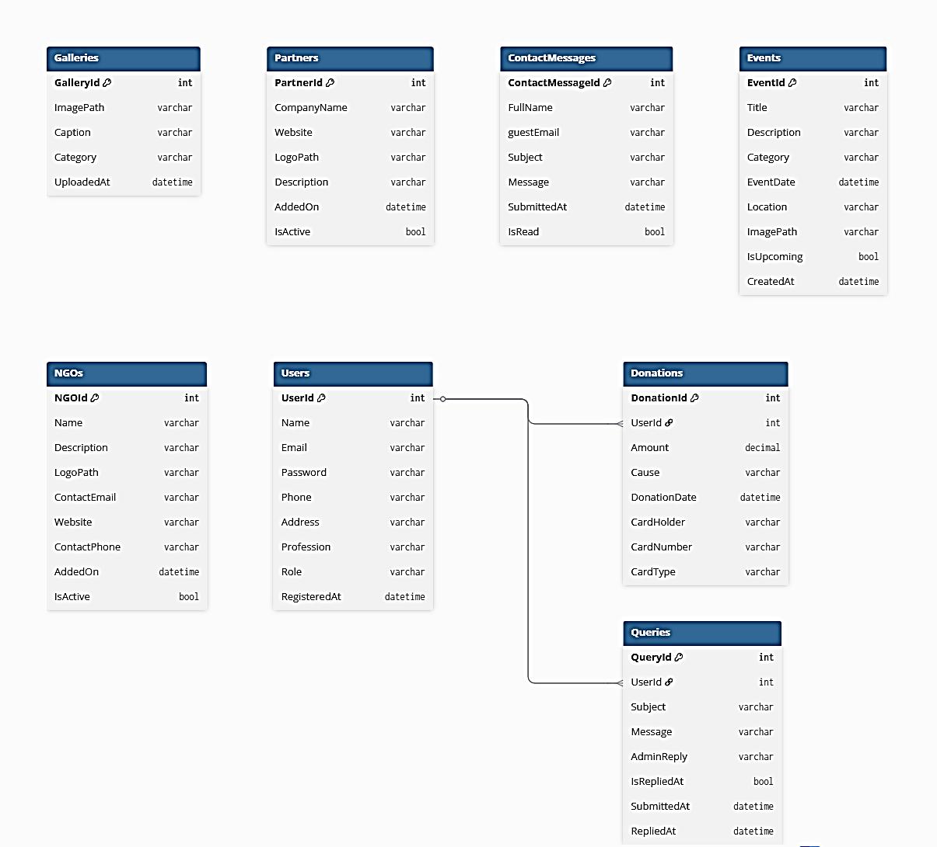

INTERFACE DESIGN DOCUMENT

1. Introduction:
This document outlines the design and interaction structure of the Give-AID platform, focusing on clear navigation, smooth workflows, and user-centric layout across all roles.
2. User Roles and Interface Responsibilities:
Role | Responsibilities / Access
User | Register, log in, view/donate to NGOs, calculate donation amounts, and submit claim/query requests
Admin | Full system access. Manages NGOs, events, gallery, users, views donations, and monitors all modules
3. Workflow Summary
➢ User Side
- Access dashboard to:
  - View NGOs and Events
  - Make a donation
  - Submit a query or support request
➢ Admin Panel
- Approves and manages NGO listings before they go public
- Can view all user activities, donation records, and reports
- Responsible for full system supervision and integrity

WORKFLOW DIAGRAMS
ADMIN DASHBOARD

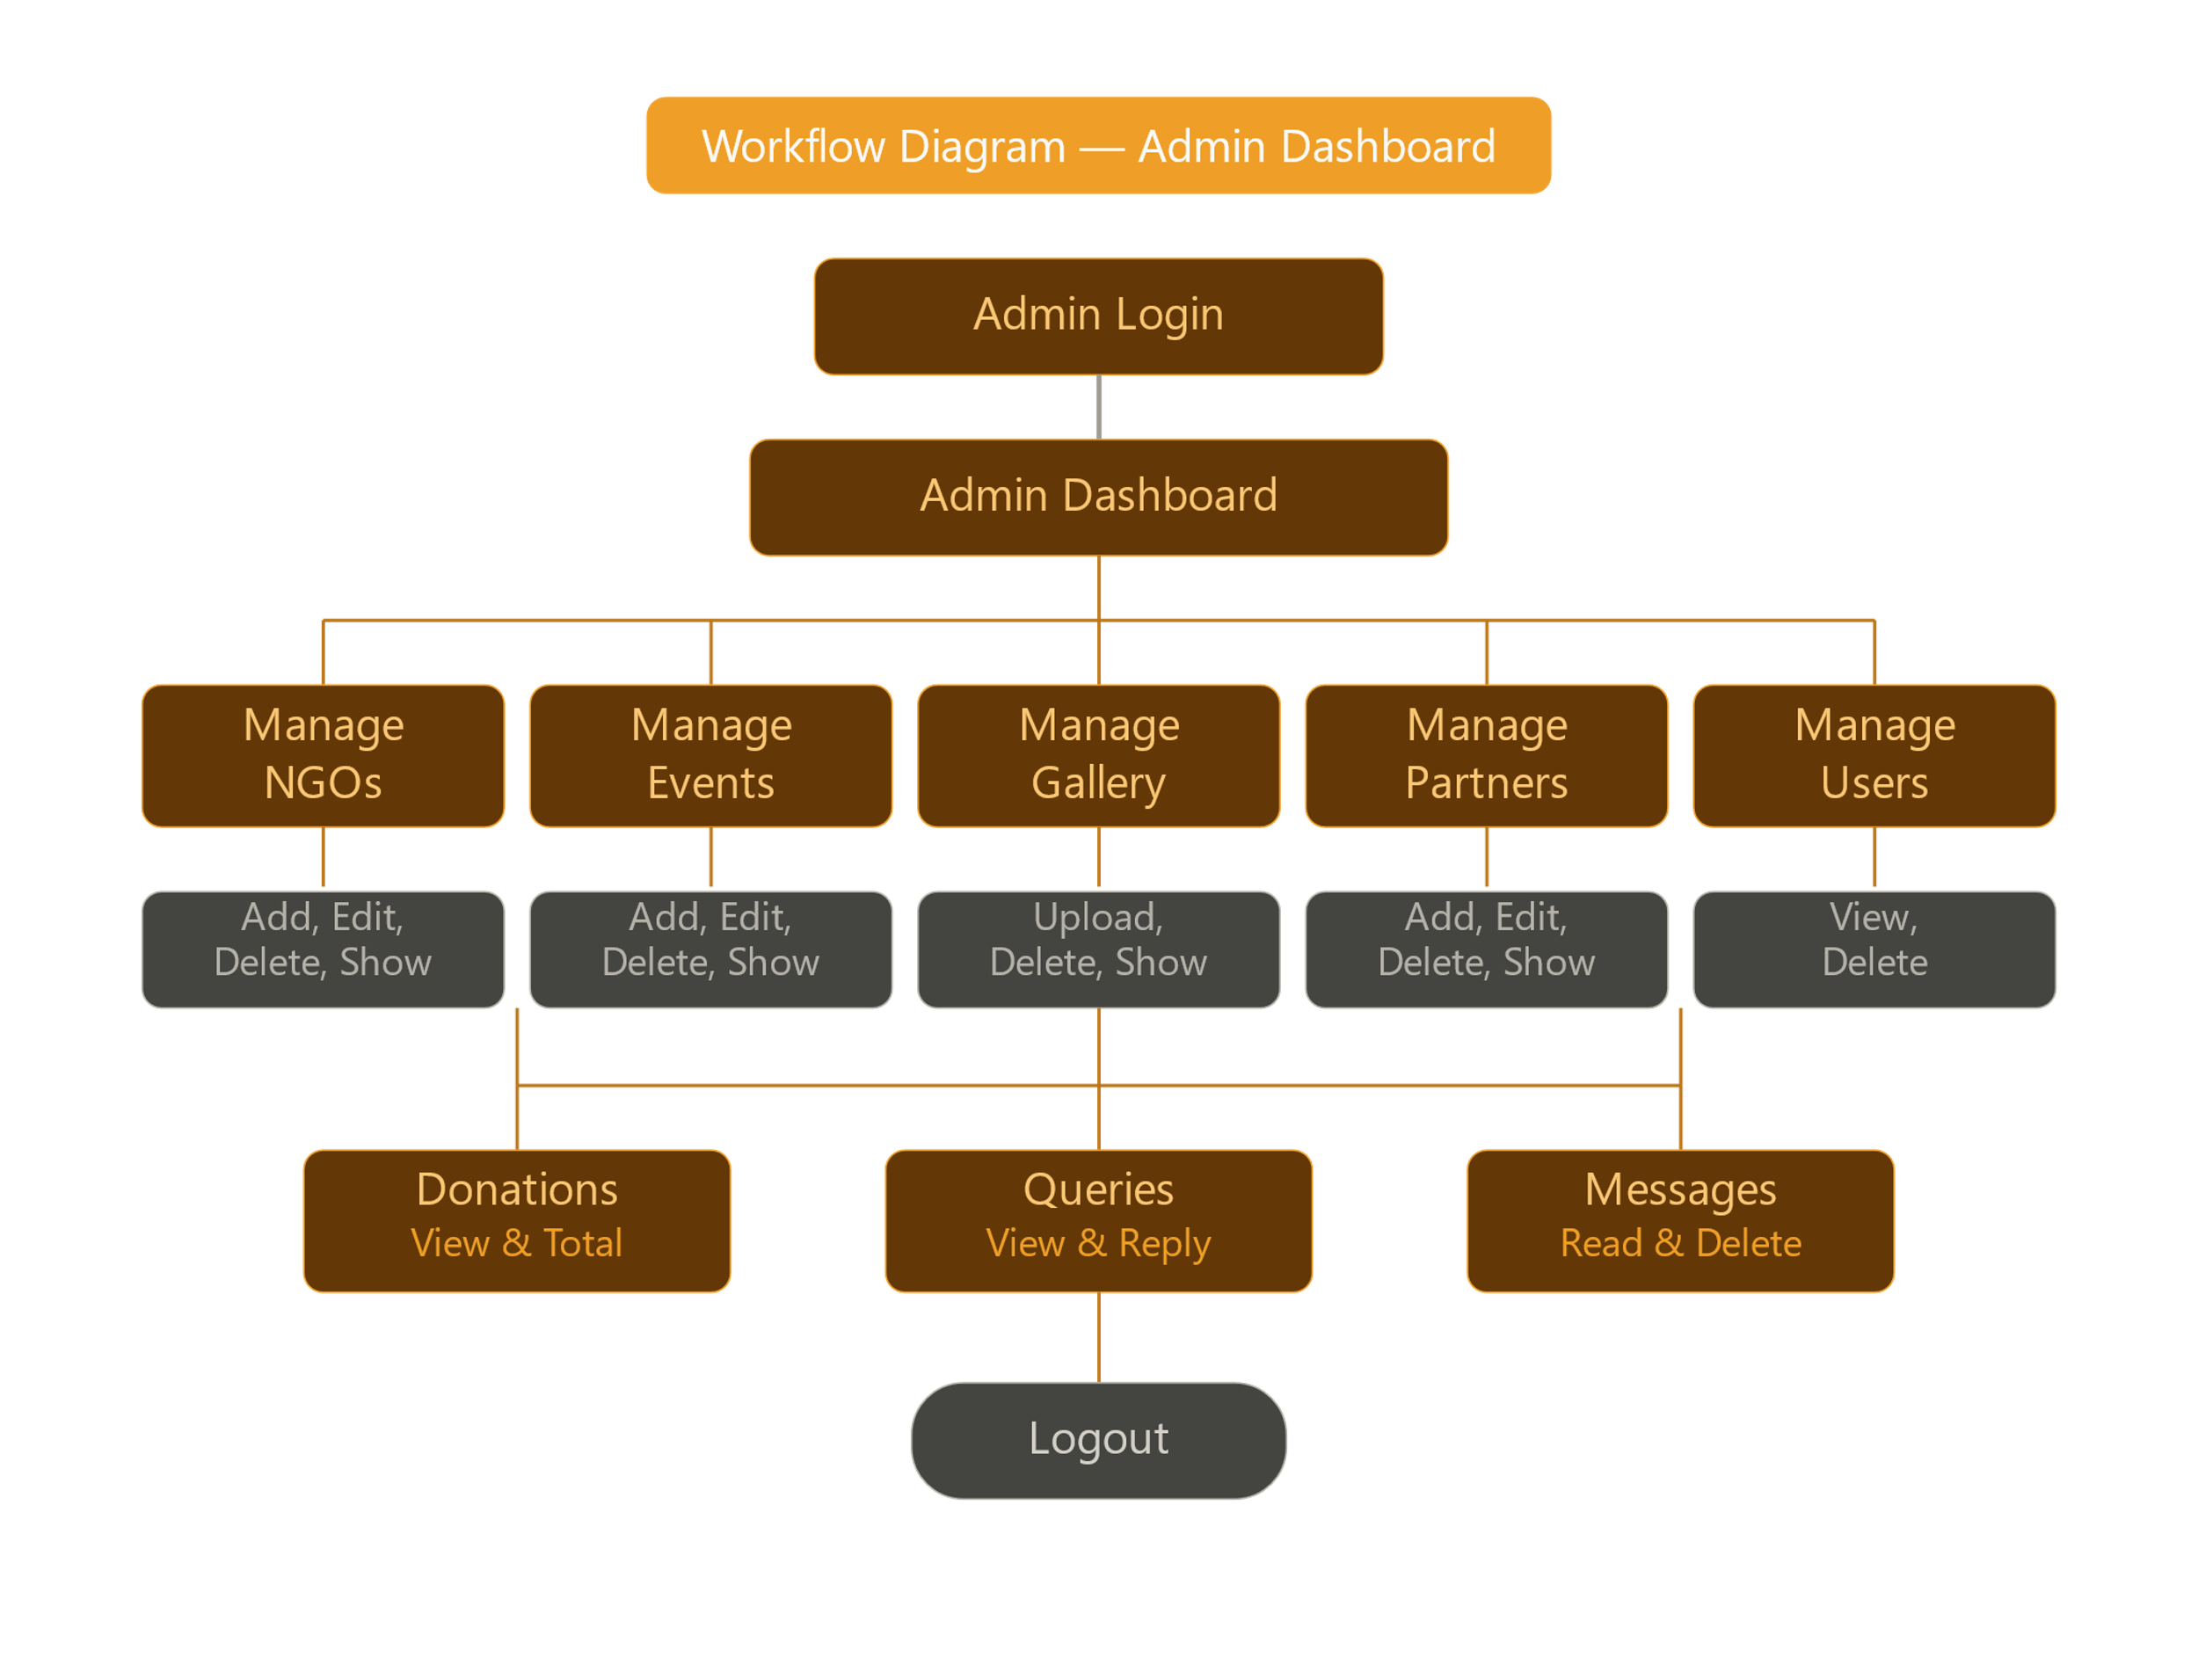

USER DASHBOARD

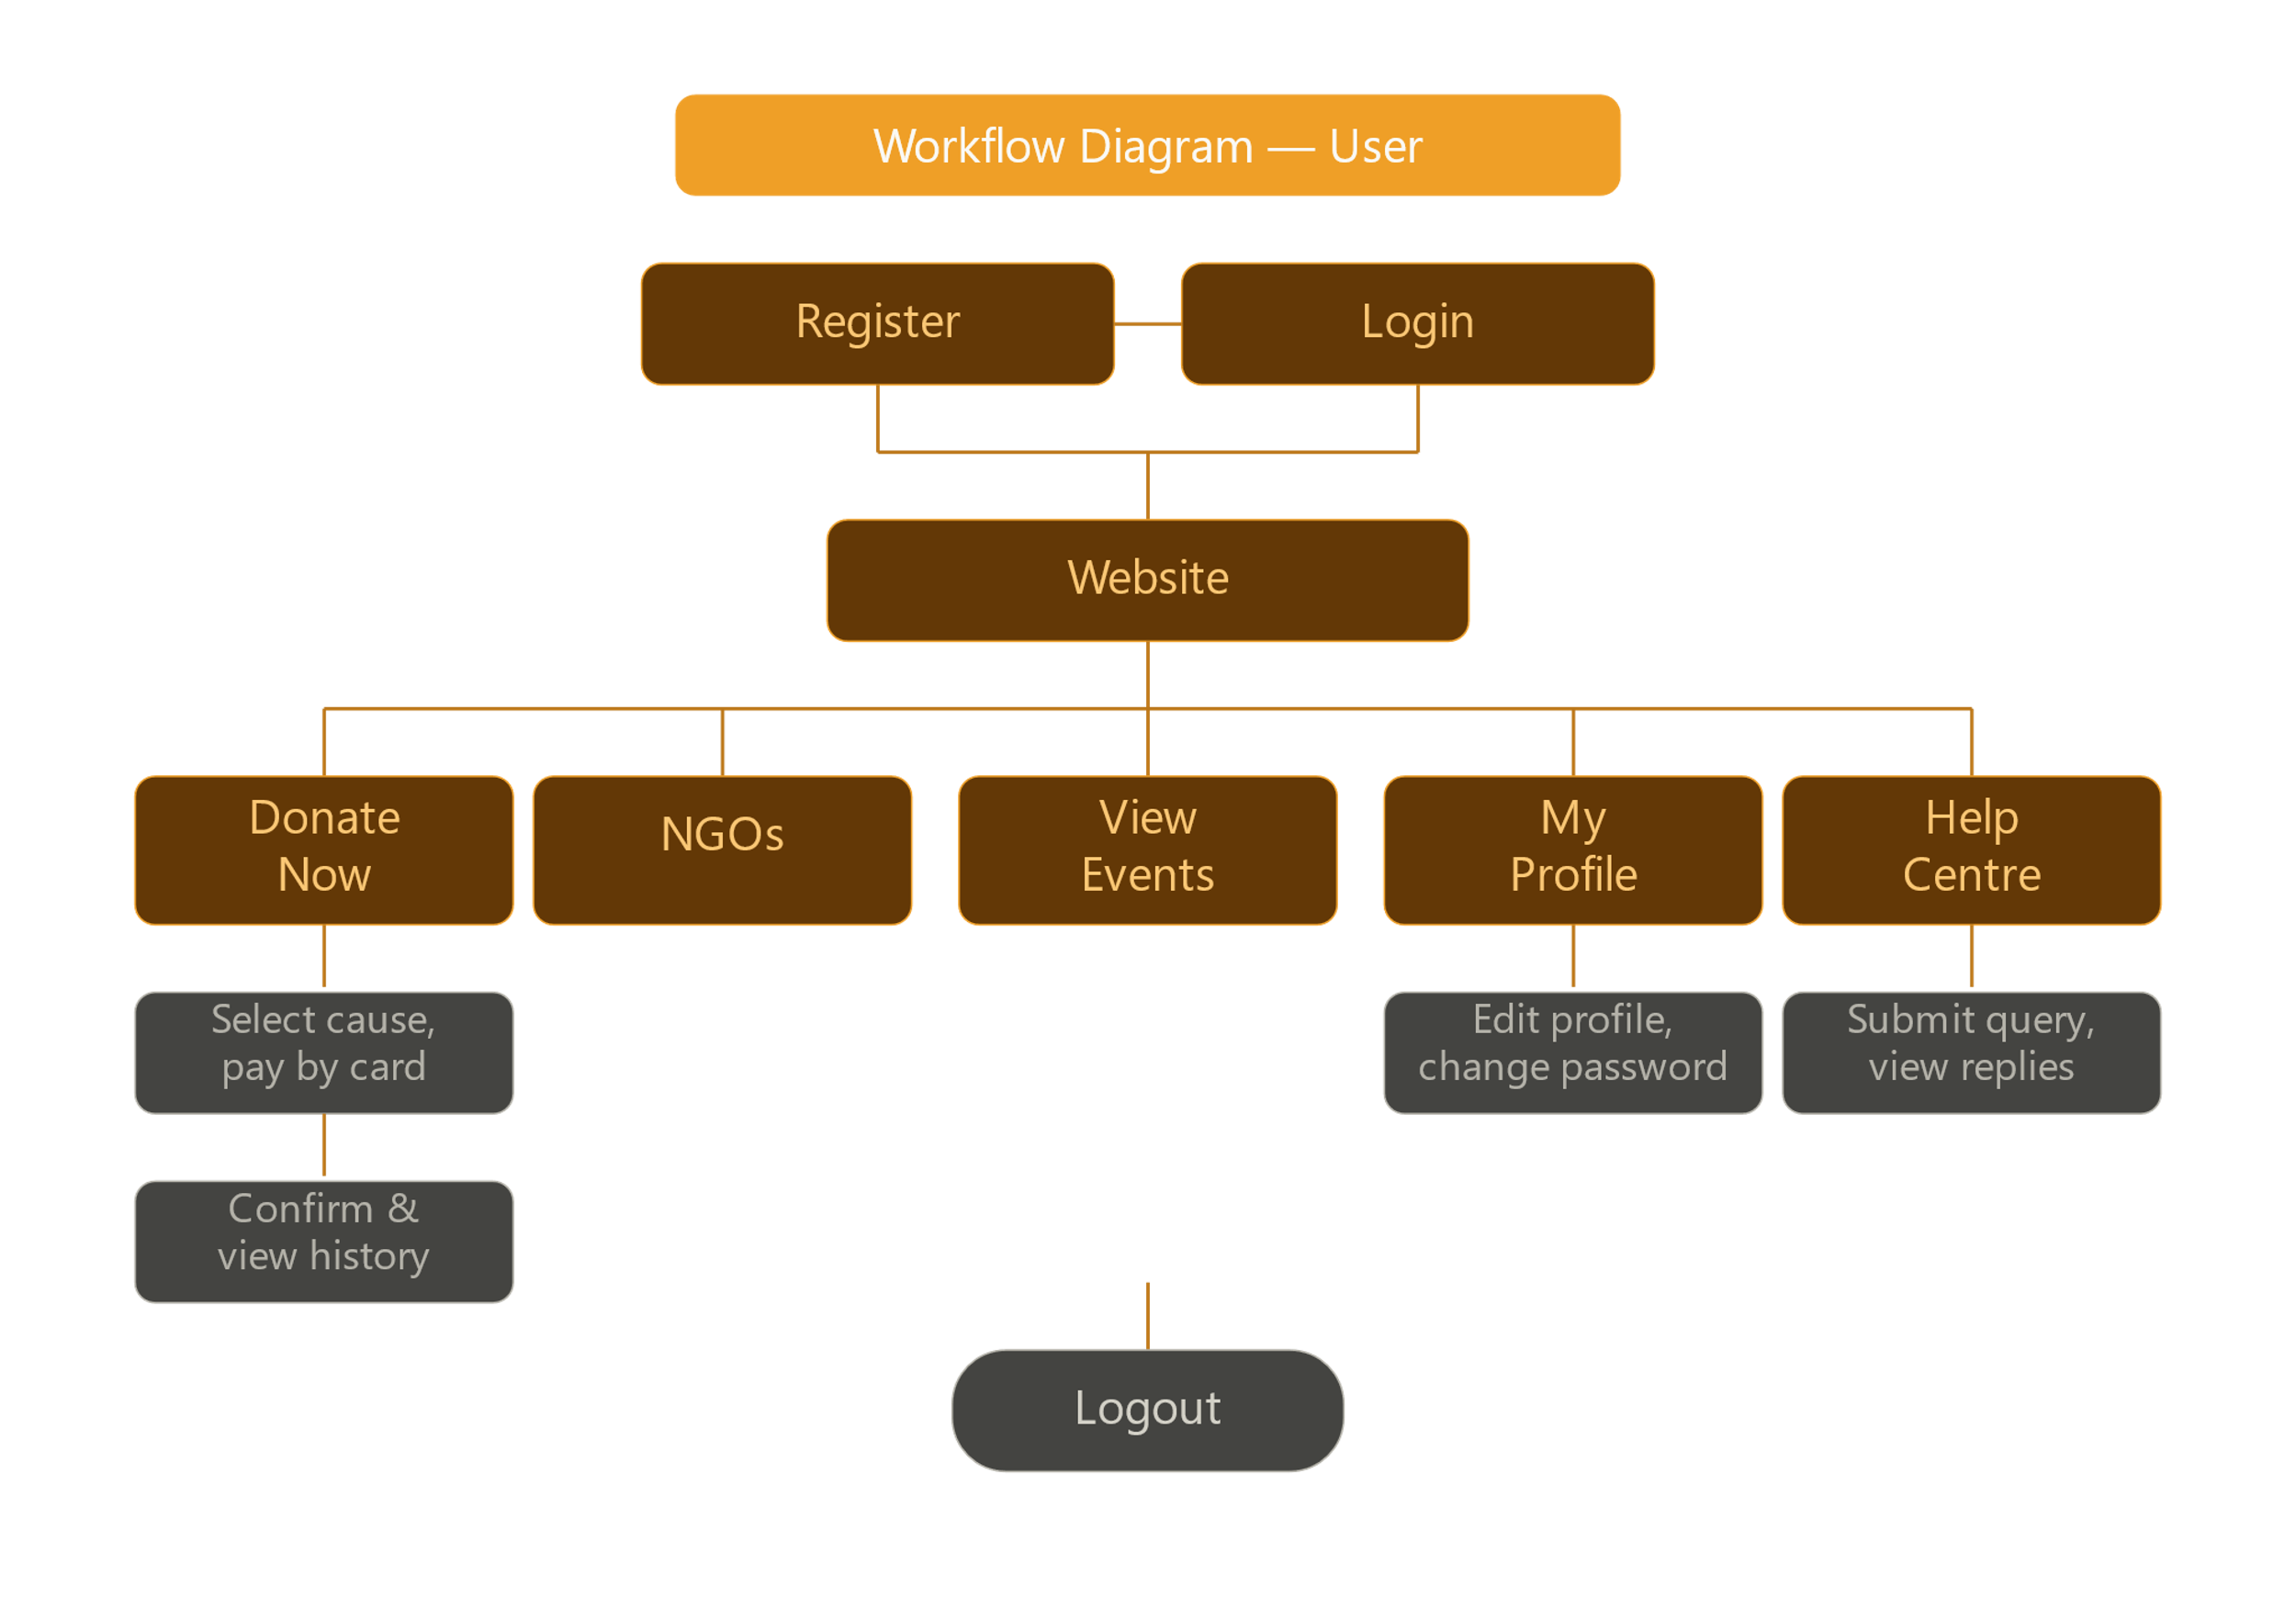

TASKSHEET
S.no | Task Description | Assigned To | Start Date | End date | Status
1 | Requirement Gathering & Project Planning | All team Members | 20-Feb | 20-Feb | ✅ Completed
2 | Database Design — ER Diagram & Schema | Sana Siddiqui | 21-Feb | 21-Feb | ✅ Completed
3 | EF Core Code-First Setup & Initial Migration | Hafsah | 22-Feb | 22-Feb | ✅ Completed
4 | Shared Layouts | Tameen Fatima | 22-Feb | 24-Feb | ✅ Completed
5 | Admin Controller & Views | Tameen Fatima | 25-Feb | 28-Feb | ✅ Completed
6 | User Controller & Views | Mahum Khan | 1-March | 4-March | ✅ Completed
7 | Home Controller & Views | Hafsah | 5-March | 8-March | ✅ Completed
8 | Donation Controller & Views | Yumna Asim | 9-March | 11-March | ✅ Completed
9 | Admin Panel — Dashboard | Tameen Fatima | 12-March | 14-March | ✅ Completed
10 | EF Core Migrations — All 11 Schema Updates Applied | Hafsah | 15-March | 15-March | ✅ Completed
11 | Integration Testing & Bug Fixes | Yumna Asim | 16-March | 16-March | ✅ Completed
12 | Documentation Preparation | Mahum Khan & Yumna Asim | 17-March | 18-March | ✅ Completed
13 | Final Report & Submission | All Team Members | 19-March | 20-March | ✅ Completed

PROJECT REVIEW AND MONITORING REPORT

Review Date | Phase Reviewed | Reviewed By | Remarks | Status
21-Feb | Requirement Gathering | Miss Kiran Shakeel | Requirements clearly understood and agreed upon by the team. Scope defined and documented. | ✅ Approved
23-Feb | Database Design | Miss Kiran Shakeel | Schema is clean and well-normalized. All 8 entities confirmed. EF Core setup verified. | ✅ Approved
1-March | Backend – All code | Miss Kiran Shakeel | Full CRUD , clean code , Sessions and etc. verified. | ✅ Approved
11-March | Frontend – Razor Views | Miss Kiran Shakeel | UI is clean and responsive across desktop and mobile. Bootstrap 4 grid applied throughout. | ✅ Approved
20-March | Final Report & Submission | Miss Kiran Shakeel | Project ready for final submission. All modules tested, documented, and verified. Well-done. | ✅ Approved

UNIT TESTING CHECKLIST
Module | Test Case | Expected Outcome | Status | Category
User Registration | Submit all valid fields, leave name field empty, leave email field empty, Password shorter than 6 characters, Password and confirm password do not match& Register with an already used email | Account created, session set, redirected to Home, "Please fill in all required fields.", "Please fill in all required fields.", "Password must be at least 6 characters.", "Passwords do not match.", "This email is already registered!" | ✅ Pass | Registration , Validation & Duplicate Check
Change Password | Correct current password, valid new password , Wrong current password entered & New password and confirm do not match | Password updated successfully, "Current password is incorrect.", "New passwords do not match." | ✅ Pass | Profile & Validation
Donation | All valid fields, 16-digit card , Amount submitted as 0, No cause selected, Card holder name left empty, Card number has only 15 digits, No card type selected, Access donation page without login & Access Success page directly without donating | Donation saved, redirected to Success page, "Please enter a valid amount.", "Please select a cause.", "Please enter card holder name, it is required.", "Card Number must be of 16 digits.", "Please select card type.", Redirected to Login with message, Redirected back to Donation form | ✅ Pass | Validation & AUTH guard
Login | Correct credentials — User role , Admin role , Wrong password entered, Empty email and password submitted & Access Profile page without login | Session set, redirected to Home/Index, Session set, redirected to Admin Dashboard, "Invalid email or password", "Please enter email and password.", Redirected to Login page | ✅ Pass | Authentication , Validation & AUTH guard
Admin | Access Dashboard as Admin, Access Dashboard as regular User, Add NGO with valid data and logo, Add NGO with empty name field, Delete a user other than self, Admin attempts to delete own account, Reply to a query with valid text & Submit empty reply to a query | Dashboard loads with all live stats, Redirected to Login page, NGO saved, redirected to Manage NGOs, "NGO name is required.", User deleted, success message shown, "You cannot delete your own account.", Reply saved, IsRepliedAt = true, RepliedAt set, "Reply cannot be empty!" | ✅ Pass | Access Control , CRUD , Validation , Business Rule , Query System
Help Centre | Submit query without login & with valid subject and message | Redirected to Login page & Query saved, success message shown | ✅ Pass | Auth guard & Query System
Gallery | Upload image with valid file selected , Submit upload form without selecting a file & Delete a gallery image | Image saved to disk, record inserted in DB, “ Please select an image." & File removed from disk, record deleted from DB | ✅ Pass | Upload ,Validation & CRUD
Contact Form | Submit with all valid fields | Message saved to DB, success message shown | ✅ Pass | Public Form

FINAL SUBMISSION CHECKLIST
Items | Status | Remarks
Complete Source Code | ✅ Submitted | All modules included
Final Documentation | ✅ Submitted | Well formatted, approved
Database File | ✅ Submitted | .SQL file exported
Unit & Integration Testing | ✅ Done | All modules tested
Teacher Review & Approval | ✅ Approved | Miss Kiran Shakeel
Project Uploaded | ✅ Done | Uploaded to Google Drive & GitHub
Screenshots attached in report | ✅ Done | As proof of execution
All EF Core Migrations Applied | ✅ Done | 11 migrations total
Admin Access Control Verified | ✅ Done | IsAdmin() guard on all routes
Donation Card Validation Verified | ✅ Done | 16-digit check confirmed
SMTP Email (Invite Friends) Tested | ✅ Done | Gmail SMTP working
Image Upload System Verified | ✅ Done | GUID filenames, disk storage

__________________________________________________________________
GiveAID — Give Help, Change Lives.
Submitted to Aptech Computer Education — March 2026
_________________________________

